# Unit Police and immigration

# Ref: “Urban issue” unit

C:\Tracy\TW related\English\IETLS\oral topic\2 EF oral topics - Script based on Level\EF L15

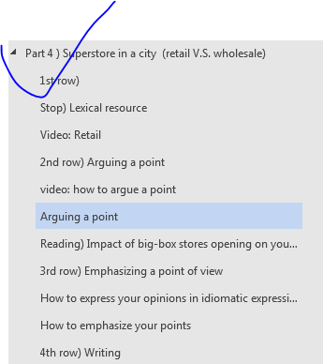

# Lexical resource

|  |  |  |  |  |  |  |  |  |  |  |
| --- | --- | --- | --- | --- | --- | --- | --- | --- | --- | --- |
| 骚乱，大混乱mayhem/ˈmeɪhɛm/: refer to a situation that is not controlled or ordered, when people are behaving in a disorganized, confused, and often violent way. **[引起了混乱cause/wreak mayhem //wreak havoc on the country ]**  e.g.  Their arrival **caused mayhem** (huge chaos, unrest, turmoil) as crowds of refugees swarmed towards them.  他们的到来**引起了混乱**，一群群难民冲向他们。  e.g. There was complete **mayhem** (huge chaos, unrest, turmoil) after the explosion. 爆炸发生后一片**混乱**。  =>synonym   |  |  | | --- | --- | | Chaos 混乱 | is a state of complete disorder and confusion. | | unrest骚乱 | If there is unrest in a particular place or society, people are expressing anger and dissatisfaction about something, often by demonstrating or rioting(暴乱, 闹事).  e.g. The real danger is civil unrest in the east of the country. 民众骚乱 | | turmoil /ˈtɜːmɔɪl/  混乱; 骚乱 | Turmoil is a state of confusion, disorder, uncertainty, or great anxiety. 混乱; 骚乱 [ political turmoil ]  e.g. She lived through the political turmoil of the French Revolution. 她经历过法国大革命的混乱之后仍旧活着 | | mayhem/ˈmeɪhɛm/  骚乱，大混乱 | 骚乱，大混乱You use mayhem/ˈmeɪhɛm/ to refer to a situation that is not controlled or ordered, when people are behaving in a disorganized, confused, and often violent way.  **[引起了混乱cause/wreak mayhem // wreak havoc on the country]** | | 暴乱, 闹事V | When there is a riot, a crowd of people behave violently in a public place, for example they fight, throw stones, or damage buildings and vehicles. 暴乱, 闹事  e.g. Twelve inmates have been killed during a riot at the prison.   十二名囚犯在该监狱里的一次 暴乱 中丧生。 | |
| **[ 担心: fret over/about sth = worry about = concern xx]**  If you fret about something, you worry about it.  e.g. I was working all hours and constantly **fretting about** everyone else's problems.  e.g. But congressional staffers **fret that** the project will eventually cost billions more.   但国会的工作人员们担心这个方案最终会多花几十亿 |
| **自夸，吹嘘〔含贬义〕[ brag about sth ]:** to talk too proudly about what you have done, what you own etc – used to show disapproval  •‘I came out top in the test,’ he bragged. “我测验得了最高分。”他吹嘘道。  [+ about]  •Ben’s always **bragging about** his success with women. 本总是吹嘘他对女人很有办法。  [brag that]  •Julia used to **brag tha**t her family had a villa in Spain. 朱莉娅以前老吹嘘她家在西班牙有一栋别墅。  V.S.  boast /bəʊst/ **[ boast about sth; boast of sth ]**  1. [V-T/V-I](javascript:;)If someone **boasts about/of** something that they have done or that they own, they talk about it very proudly, in a way that other people may find irritating or offensive. 吹嘘  •  Witnesses said Furci **boasted t**hat he took part in killing them.   证人们说富尔西曾吹嘘说他参与了杀人。  •  Carol **boasted about/of** her costume.   卡罗尔吹嘘着她的戏装。  2. [N-COUNT](javascript:;)Boast is also a noun. 吹嘘  e.g. It is the charity's proud boast that it has never yet turned anyone away.  该慈善机构自吹自擂，声称从来没有拒绝过任何人 |
| linger /ˈlɪŋ**ɡə**/  1.[V-I](javascript:;)When something such as an idea, feeling, or illness lingers, it continues to exist for a long time, often much longer than expected. (想法、感觉、疾病) 存留满久的，持续满久的， 久久不消失的  •  The scent of her perfume **lingered**/ˈlɪŋ**ɡə**/  on in the room.   她的香水味在房间里 **久久不散**。  •  He was ashamed. **That feeling lingered**, and he was never comfortable in church after that.  这种感觉 **持续满久的**  2.[V-I](javascript:;)If you **linger somewhere**, you stay there for a longer time than is necessary, for example, because you are enjoying yourself. 继续逗留  •  Customers are welcome to **linger/ˈlɪŋɡə/  over** coffee until around midnight.   顾客们可以慢慢品味咖啡到午夜。  =>adj lingering **['lɪŋgərɪŋ]** (想法、感觉、疾病) 存留满久的，持续满久的，久久不消失的  e.g. The trouble in the market began early last week, when investors focused on a number of **lingering concerns ['lɪŋgərɪŋ拖了很久的（病），久久不散的.** If the economy gets much stronger, it could touch off inflation, which has been mysteriously missing for the nine years of the post-crisis recovery. That could force the Federal Reserve to raise interest rates faster than planned.  e.g. Mr Wilkins suffered **a lingering death**. 威尔金斯先生拖了很久才咽气  e.g. the **lingering** aroma of chocolate 久久不散的巧克力香味 |
| (会谈，政治对话的) 对话者；谈话者 interlocutor  [,ɪntə'lɒkjʊtə] your interlocutor is the person you are speaking to.  [词条图片](javascript:;) |
| **[ 有约束力的决定: a binding decision; 一种具有法律约束力的决定: a legally binding decision; 没有约束力的决议: a non-binding decision ]**  e.g.The CHMP's recommendation has now been forwarded to the European Commission for the adoption of a legally binding decision.  以便作为一种具有法律约束力的决定而被采用。  e.g. from the perspective of the North Koreans, they will want **interlocutors** who have the authority to make **a binding decision有约束力的决定**, pending President Moon's approval, about the North's participation.  2. China has already ruled out a joint referral to the tribunal, but del Rosario said it is possible for acountry to go to the panel unilaterally for a non-binding decision.  寻求一个单方的专家组做出没有约束力的决议对一个国家来说还是有可能的。  3. May I remind everyone that this committee has authority to make a binding decision.  有权做 约束性的决定。 |
| 插入一根不谐锲子, **制造分裂,** 种下不和的种子: **drive a hedge; drive a hedge between A and B.**   * + 1. The president accused his hardline rivals of trying to **drive a wedge between him and the man** whosits at the top of Iran's clerical leadership and has final say in all state matters. 对手冀图在他和卡梅尼之间插入一根不谐锲子(**制造分裂**)，离间两人之间的关系。     2. E.g. There is concern in Seoul that Pyongyang's insistence on holding bilateral talks with Washingtoncould drive a wedge between the U.S. and South Korea.  平壤坚持要同华盛顿举行双边会谈，这可能在美国和韩国之间种下不和的种子   They're talking about **appeasement** of the North, of Pyongyang using its potential participation in the Olympics as a way to extract **concessions** on issues of geostrategic concern, and to give voice to a "sky is falling" perspective that Pyongyang is attempting to **drive a wedge制造分裂** in the South Korean-US alliance. |
| [əʊvə'rɔːt] overwrought  adj. 过度紧张的；过度兴奋的；过分劳累的；（文体等）过于考究的  v. 工作过度；把…做过头；使过于激动（overwork的过去式和过去分词: overwork, overwrought, overwrought）  very upset, nervous, and worried  非常烦恼的；神经很紧张的；十分忧虑的  e.g. Clara was tired and overwrought after all the problems of the last few days. 经历了过去几天的重重困难之后，克拉拉既疲惫又紧张。  E.G. The fact that South Korean President Moon Jae-in even proposed the meeting, in response to remarks Kim Jong-un made during his New Year's Day address, has sent some analysts into making overwrought([‚əʊvə'rɔːt◂ over upsetting and nervous) and heavy handed pronouncements. |
| Substance = substantive, substantively ['sʌbst(ə)ntɪv] [səb'stæntɪv]  dealing with things that are important or real 实质的；真实的，实际的 **[ substantive matters/issues; 实质性的商谈: substantive disucssions; 实质性的进展substantive progress ]**  e.g. The State Department reported that substantive discussions had taken place with Beijing. 美国国务院称已经和北京方面进行了实质性的商谈。  e.g. President Moon's proposal for North Korean participation in the Winter Olympics is an incremental step that might eventually lead to further, more **substantive实质性的** interactions between the North and South. |
| [mɪs‚kælkjʊ'leɪʃ ə n,mɪs‚kælkjə'leɪʃ ə n]  miscalculation   1. a mistake made in deciding how long something will take to do, how much money you will need etc 误算，错算 2. a wrong judgment about a situation 〔对局势的〕错误判断   But if the North does participate in the Olympics and manages to keep its lines of communication open this reduces the **likelihood** of **miscalculation /'mis,kælkju'leiʃən/ 〔对局势的〕错误判断** (on both sides) which could escalate into a military conflict. |
| **后门；非法途径; 不正规的途径** [ back door; 走后门: get in through the back door ]   * back door: a secret or underhand means of access (to a place or a position) * get in through the back door: to achieve something by having an unfair secret advantage   e.g. His father works there, so he got in through the back door. 他父亲在那里做事，所以他走了后门。 |

# Lexical_Law/Crimes

# STOP ======

|  |
| --- |
| Seize, ['siːʒə] seizure   1. [C,U] the act of suddenly taking control of something, especially by force   夺取；占领，控制; If there is a seizure of power or a seizure of an area of land, a group of people suddenly take control of the place, using force. 占领 e.g.   ...the seizure of territory through force. …对领土的武装占领 e.g. the fascist seizure of power in 1922 1922 年法西斯的夺权   1. [C,U] when the police or government officers take away illegal goods such as drugs or guns 〔警方或政府官员对毒品、枪支等的〕查获，没收; When an organization such as the police or customs makes a seizure of illegal goods, they find them and take them away. 缴获; 没收   e.g.  Police have made one of the biggest seizures of heroin there's ever been. 这次缴获的海洛因是迄今为止数目最大的几宗之一 e.g.drugs seizures 查获毒品  3. [C] a sudden condition in which someone cannot control the movements of their body, which continues for a short time 〔疾病的〕突然发作; If someone has a seizure, they have a sudden violent attack of an illness, especially one that affects their heart or brain. (心脏病、脑部疾病等的) 突然发作  e.g. ...a mild cardiac seizure.   …一次轻度心脏病发作 e.g. He had an epileptic seizure . 他突然癫痫发作。 |
| mule /mjuːl/     1. A mule is an animal whose parents are a horse and a donkey. 骡  2. A mule is a shoe or **slipper** which is open around the heel. 拖鞋式便鞋; 拖鞋  3. [**[ human mules ]**](javascript:;)**a person who is paid to transport illegal drugs for a dealer 受雇贩,走私运毒品者 e.g. Illegal goods are smuggled by human mules.** |
| intercept /ˌɪntəˈsɛpt/ => interception n /-ˋsɛpʃən ; -'sepʃən / [C,U]    1.  [V-T](javascript:;)If you intercept someone or something that is travelling from one place to another, you stop them before they get to their destination. 拦截  •  Gunmen intercepted him on his way to the airport.   持枪人在他去机场的路上截住了他。  2. [N-VAR](javascript:;)拦截  •  ...the interception of a ship off the coast of Oregon.   …对一艘驶离俄勒冈海岸的轮船的拦截。  to stop something or someone that is going from one place to another before they get there  拦截，截住，阻截  •an attempt to intercept drugs being smuggled over the border 阻截毒品走私入境的努力  •His phone calls were intercepted. 他的电话被截听了。  DERIVATIVE 派生词 |
| [**informant’s tip-off线人的线报**]  e.g. You followed up on your **informant’s tip-off线人的线报**, and seized a shipment of illegal tobacco products brought in by ship. Which points will you include in your report? Which will you leave out? |
| **大毒枭drug lord /ˈdrʌɡˌlɔːd/**[**N**](javascript:;)**a criminal who controls the distribution and sale of large quantities of illegal drugs**  V.S.  [drug cartel]  e.g. Banditeros aspired to become the baron of a multimillion-dollar drug cartel . |
| /ræ'pɔː,ræˋpɔr/ n. [singular 单数,U]  英 [ræ'pɔː]  MEANINGS 义项  friendly agreement and understanding between people 融洽，和睦关系; rapport /ræˈpɔː/     e.g. Well first off, we need to **establish rapport with** him  |TEM8  [N-SING](javascript:;)If two people or groups have a rapport, they have a good relationship in which they are able to understand each other's ideas or feelings very well. 融洽  •  The success depends on good rapport between interviewer and interviewee.   成功取决于采访者和被采访者之间的融洽。  RELTD RELATIONSHIP  [+ with/between]  •He had an excellent rapport with his patients. 他和他病人的关系极为融洽。  establish/build up/develop (a) rapport  •He built up a good rapport with the children. 他和孩子们建立了融洽的关系。 |
| [ɪ'lɪsɪt,ɪ'lɪsət]  MEANINGS 义项  to succeed in getting information or a reaction from someone, especially when this is difficult  〔从某人处〕套出〔信息〕；引起〔某人的反应〕  •When her knock elicited no response, she opened the door and peeped in. 敲门没有回应，她便推开门往里张望。  elicit sth from sb; If you elicit a piece of information, you get it by asking the right questions. 探得 (信息)  •  My letters to her have elicited no response.   我写给她的信没有得到回应  •The test uses pictures to elicit words from the child. 这项测试用图片诱导孩子说话。  DERIVATIVE 派生词  elicitation n /ɪ͵lɪsəˋteʃən ; ɪ‚lɪsɪe_ʃɝːp'teɪʃən,ɪ‚lɪsəe_ʃɝːp'teɪʃən / [U]  If you elicit a response or a reaction, you do or say something that makes other people respond or react. 引起 (反应)  •  Mr. Norris said he was hopeful that his request would elicit a positive response.   诺里斯先生说他希望他的要求会引起积极的回应。  e.g. We need to think carefully about how to elicit 引出/套出information from a detained suspect |
| accomplice /əˈkɒmplɪs/      |CET6+ TEM8  [N-COUNT](javascript:;)Someone's accomplice is a person who helps them to commit a crime. 同犯  •  Witnesses said the gunman immediately ran to a motorcycle being ridden by an accomplice.   证人们说该枪手立即向由一名同犯驾驶的摩托车跑去。  V.S.  accessory /əkˈsɛsərɪ/     3.  [N-COUNT](javascript:;)If someone is guilty of being an accessory to a crime, they helped the person who committed it, or knew it was being committed but did not tell the police. 从犯  •  She had been charged with being an accessory to the embezzlement of funds from a cooperative farm.   她已被指控为挪用一个合作农场资金的一个从犯。 |

|  |  |
| --- | --- |
| 轻视；贬低(什么事情) | Little => [ belittle sth /bɪˈlɪtəl/ ]    [V-T](javascript:;)If you belittle someone or something, you say or imply that they are unimportant or not very good; formally to make someone or something seem small or unimportant; 轻视；贬低  •He tends to **belittle her efforts**. 他往往 **轻视她的努力**  •  We mustn't **belittle her outstanding achievement**.  我们不应该 **轻视她的杰出成就**。  V.S.  downplay sth /ˈdaʊnˌpleɪ/: If you downplay a fact or feature, you try to make people think that it is less important or less serious than it really is. 对（事情，事实，功能）轻描淡写  e.g.  Police sources yesterday downplayed the significance of the security breach.   警方昨天的消息对这次安全缺口的重要性轻描淡写。 |
| 1. **控制和操纵 (某人/某人的思想)**  2. 控制和操纵 (event) 3. **(熟练有技巧的**)操作（计算机， 设备） 4 .使脱臼复位; 用推拿术治疗 4.为达到个人目的而进行的操作, 窜改 (file/account) | manipulate /məˈnɪpjʊˌleɪt/ , manipulation: [mə,nɪpjʊ'leɪʃ(ə)n]  1. **控制和操纵（某人；某人的思想); 控制/操纵sb做xxx** If you say that someone **[ manipulates people to do sth]** , you disapprove of them because they skilfully force or persuade people to do what they want.  e.g. She's always **manipulating me to** give her vast sums of money. 控制我让我给她大笔的钱。  e.g. I'm not a **pushover**. Don't wanna **manipulate me 控制操纵我**. I'm sticking to my principle and I'm a principled person (我是一个有原则的人）  2.控制和操纵(event) If you say that someone manipulates or rigs a (political) event or situation, you disapprove of them because they use or control it for their own benefit, or cause it to develop in the way they want.  e.g The president was unable, for once, to control and manipulate/rig events. 她曾一度无法控制和操纵事件。  => N. 对xxx的控制/操纵 manipulation [ ...accusations/indictment of his political manipulation/rigging.…对政治操纵的指控; ... an indictment for his manipulation of the real-estate market 对他对房地产市场操纵的指控] [ manipulation of our minds 对我们思想的控制/操纵; manipulating its currency 操纵货币; a currency manipulator 货币操纵者/货币操纵国) ]  e.g. Mr Trump has also criticised Japan for trade barriers (tariff, quota) to American car exports and for manipulating its currency 操纵货币 to gain a competitive advantage.  e .g. America's trade deficit with Germany was $67 billion, and with Japan it was $56 billion last year. Director of the White House National Trade Council, criticized Japan and Germany for manipulating their currencies 操作货币 to make their exports cheaper and more competitive against the U.S.  e.g. Despite having congratulated Mr Xi on his political ascendency, Mr Trump has been a vocal critic over what he sees as unfair Chinese trade practices. During his presidential campaign, he called Beijing **a currency manipulator(货币操纵国)** and accused it of stealing US jobs.   5. (熟练有技巧的)操作（计算机， 设备） If you manipulate something (such as computer, devices) that requires skill, such as a complicated piece of equipment or a difficult idea, you operate it, manage it, handle it or process it with profession and skills.  e.g. The technology uses a pen to **manipulate a computer**. 这项技术使用笔来 (熟练有技巧的)操作计算机。  => manipulation e.g. ...science that requires only the simplest of **mathematical manipulations.** …只要求进行最简单数学运算的科学。  7. 使脱臼复位; 用推拿术治疗 If someone manipulates your bones or muscles, they skilfully move and press your bones or muscles with their hands in order to push the dislocated bones into their correct position or make the muscles less stiff.  e. g. The way he can manipulate my leg has helped my arthritis[ɑ:'θraitis] so much. 他针对我的腿部做的推拿治疗对我的关节炎大有帮助。  => N. 推拿术 manipulation e.g. A permanent cure will only be effected by acupuncture针灸, chiropractic按摩, or manipulation推拿术.  //If you dislocate a bone or joint in your body, or in someone else's body, it moves out of its proper position in relation to other bones, usually in an accident. 使脱臼 my dislocated shoulder/jaw  9. **manipulate a file or account= to falsify or fake sth in a fraudulent/deceptive manner 为达到个人目的而进行的操作或欺诈, 窜改** sth [ manipulate/falsify accounts 窜改(帐目等); manipulate files = falsify file 窜改文件； manipulate testimony = falsify testimony 窜改证词 => perjury: 作伪证] [fraud: business fraud/scam/shenanigan; fraudulent = intended to deceive/sucker sb]  e.g. Russia's athletes face a nervous wait to see if a blanket ban全面禁止令 will be imposed with the IOC announcing it will retest all of its track and field athletes which competed at the 2014 Winter Olympics in Sochi. That's because an independent report published by Canadian law professor found that urine samples of Russian competitors were manipulated/falsified 窜改 across the winter Olympic sports from 2011 through to August 2015. The IOC has also asked the Canadian lawyer to give all names of those who were implicated牵连卷入 in allegations of manipulating窜改 drug tests.  //sucker sb into doing sth = deceive sb. //bogus ['bəʊgəs] acccount = faked account |

|  |
| --- |
| ['kɒntrəbænd] contraband = smuggling goods  [N-UNCOUNT](javascript:;)Contraband refers to goods that are taken into or out of a country illegally. 走私品；战时禁运品（等于contraband of war） adj. 禁运的；非法买卖的  e.g.  The ship was carrying contraband. 这只船携带走私货。  e.g.  The markets were flooded with contraband goods.  市场上充斥着走私物品。  e.g. Border control agents see various types of **contraband走私货** daily, from illegal drugs to **counterfeit money/banknotes (假币)** to **knock-off (counterfeit) branded merchandise** and commodities.  The demand for these illegal goods requires agents to be constantly observant at entry points, including sea ports, airports, and land crossings. Among those **knock-off/counterfeit goods**, the illegal drugs are the most headache.  Drug smuggling/trafficking is a multibillion-dollar industry with an extensive network of **growers**, **smugglers**, and **human mules** all working together to distribute illegal drugs around the world.  //[**[ human mules ]**](javascript:;)**a person who is paid to transport illegal drugs for a dealer 受雇贩,走私运毒品者 e.g. Illegal goods are smuggled by human mules.**  ## Social impact by illegal drugs  Illegal drugs affect all aspects of society, causing/wreaking a rise in violent crime, spreading detrimental diseases such as HIV virus, and even funding organized **crime syndicates(黑社会).** The drug trade is often connected to the distribution of **knock-off/counterfeit products假冒商品/赝品** and even **counterfeit money/banknotes(假币)**.  Although police officers and law enforcement officials are trained to recognize illegal goods and false documents, they also see the help of **sniffer dogs** as well as ordinary citizens to detect **contraband**走私货. |
| pirate /ˈpaɪrɪt/   1. [N-COUNT 可数名词](javascript:;)Pirates are sailors who attack other ships and steal property from them. 海盗  e.g.  In the nineteenth century, pirates are crazy over the seas. 海盗很猖獗。 2. [V-T](javascript:;)Someone who pirates CDs, DVDs, books, or computer programs copies and sells them when they have no right to do so. 盗版 (CD、DVD、书籍、计算机程序等)  **[ pirated DVDs; pirated CDs; pirated books; pirated software盗版软件; pirated copies of music and movies盗版音乐和影片]** e.g. Computer crimes include data theft and pirated software. 计算机犯罪包括数据窃取和 盗版软件。 e.g. New technology makes it possible to make pirated copies of music and movies.  新技术使制作盗版音乐和影片成为可能。 3. [ADJ](javascript:;)A pirate version of something is an illegal copy of it. 盗版的 e.g. Pirate copies of the DVD are already being sold. 该DVD的盗版已经有售了。 |
| 〔e.g. DA (domestic abuse家庭暴力)皮肤被打得〕青一块紫一块的；遍体鳞伤的有瘀痕的 **[ black and blue ]** ['blæk**ən**'blu:] skin that is black and blue has bruises (dark marks ) on it as a result of being hit, esp. because of domestic abuse (DA).  e.g. Dad: If you do that again, I’ll beat you black and blue['blæk**ən**'blu:] 我就把你打个鼻青脸肿。  V.S.  [bruː**z**] bruise   1. a purple or brown mark on your skin that you get because you have fallen, been hit etc; A bruise is an injury that appears as a purple mark on your body, although the skin is not broken. 瘀青，青肿，擦伤  e.g.minor cuts and bruises on my arms 轻微的伤口和淤青 e.g. How did you get that bruise on your cheek?  你脸颊上怎么有一块瘀伤？ 2. V. If you bruise a part of your body, a bruise appears on it, for example, because something hits you. If you bruise easily, bruises appear when something hits you only slightly. 使受瘀伤; 受瘀伤 e.g. I had only **bruised my knee**.  我只是膝盖受了瘀伤。 3. [V-T/V-I](javascript:;)If a fruit, vegetable, or plant bruises or is bruised, it is damaged by being handled roughly, making a mark on the skin. (水果、蔬菜等) 碰伤  e.g.  Choose a warm, dry day to cut them off the plants, being careful not to bruise them.   选择暖和干燥的一天把它们从植物上剪下来，小心不要碰伤它们。 e.g....bruised tomatoes and cucumbers.   …碰伤了的西红柿和黄瓜。 4. [N-COUNT](javascript:;)Bruise is also a noun. (水果、蔬菜等表皮上) 碰的伤痕  e.g...bruises on the fruit's skin. …水果表皮上的碰的伤痕。 5. [V-T](javascript:;)If you are bruised by an unpleasant experience, it makes you feel unhappy or upset because of the setbacks 受挫  e.g.  The government will **be severely bruised** by yesterday's events.   政府将因昨天的事件而严重受挫。 |
| cartel /kɑːˈtɛl**/ [ drugs cartel 毒品联盟 ]**  A cartel is an association of similar companies or businesses that have grouped together in order to prevent competition and to control prices; a cartel is a group of people or companies who agree to sell something at a particular price in order to prevent competition and increase profits 同业联盟  一伙人或多家公司为限制竞争和增加利润而结成的固定价格联盟〕  synonym: monopoly [mə'nɒp(ə)lɪ]  V.S.  syndicate: A syndicate is an association of people or organizations that is formed for business purposes or in order to carry out a project. 联合组织 **e.g. crime syndicate黑社会; IETLS syndicate; bank syndicate银行联合组织** |
| eradicate sth: eradication; eradicate sth: to tear up sth by roots, root out sth; abolish/repeal sth completely.  **[ eradicate hunger; eradicate diseases; eradicate poverty (彻底)根除贫困; eradicate slavery (彻底)根除奴隶制; eradicate human trafficking(彻底)根除人口贩卖; eradicate children trafficking 彻底)根除儿童贩卖; eradicate drug trafficking 彻底)根除药品贩卖; Bacteria Eradication 杀菌功能 ; 细胞清除率 ; 细菌清除]**  => n) (彻底)根除贫穷eradication of poverty; (彻底)根除奴隶制eradication of slavery; (彻底)根除儿童贩卖eradication of children trafficking]  eg By releasing her from judicial custody and dropping any charges against her, the justice ministry could send an important message: That it's finally getting serious about providing justice and eradicating slavery (彻底)根除奴隶制. |

|  |  |
| --- | --- |
| vt. 伪造，仿造赝品/冒牌货；假装伪装  n. 赝品/冒牌货；伪造品  adj. 假冒的，伪造的；虚伪的 | ['kaʊntɚ'fɪt] counterfeit , n) counterfeiting  vt. 伪造，仿造赝品/冒牌货；假装伪装: make illegal copies for profit  n. 赝品/冒牌货；伪造品 a counterfeit = a fake one, not genuine  adj. 假冒的，伪造的；虚伪的  **counterfeit /ˈkaʊntəfɪt/  = knock-off**  **[ fake products = counterfeit products = knock-off products V.S. genuine products ]**   1. [ADJ](javascript:;)Counterfeit money, goods, or documents are not genuine, but have been made to look exactly like genuine ones in order to deceive people. 伪造的 e.g.  He admitted possessing and delivering **counterfeit currency**.   他承认持有和运送了 假币。**[ counterfeit goods/commodities; counterfeit money/banknotes]** 2. [N-COUNT](javascript:;)Counterfeit is also a noun. 仿制品; 伪造品; 赝品 e.g. The **counterfeits of the company's jeans** are flooding Europe.  牛仔裤的仿冒品充斥着欧洲市场。 3. [V-T](javascript:;)If someone counterfeits something, they make a version of it that is not genuine but has been made to look genuine in order to deceive people. 仿冒; 伪造  e.g. ...the coins Davies is alleged to have counterfeited.   …这些据称是戴维斯伪造的硬币。   e.g. Border control agents see various types of **contraband走私货** daily, from illegal drugs to **counterfeit money/banknotes (假币)** to **knock-off (counterfeit) branded merchandise** and commodities.  The demand for these illegal goods requires agents to be constantly observant at entry points, including sea ports, airports, and land crossings. Among those **knock-off/counterfeit goods**, the illegal drugs are the most headache.  Drug smuggling/trafficking is a multibillion-dollar industry with an extensive network of **growers**, **smugglers**, and **human mules** all working together to distribute illegal drugs around the world.  //[**[ human mules ]**](javascript:;)**a person who is paid to transport illegal drugs for a dealer 受雇贩,走私运毒品者 e.g. Illegal goods are smuggled by human mules.**  ## Social impact by illegal drugs  Illegal drugs affect all aspects of society, causing/wreaking a rise in violent crime, spreading detrimental diseases such as HIV virus, and even funding organized **crime syndicates(黑社会).** The drug trade is often connected to the distribution of **knock-off/counterfeit products假冒商品/赝品** and even **counterfeit money/banknotes(假币)**.  Although police officers and law enforcement officials are trained to recognize illegal goods and false documents, they also see the help of **sniffer dogs** as well as ordinary citizens to detect **contraband**走私货. |
|  | **[ knock-off goods = counterfeit good; knock-off commodities = counterfeit commodities]**  e.g. Border control agents see various types of **contraband走私货** daily, from illegal drugs to **counterfeit money/banknotes (假币)** to **knock-off (counterfeit) branded merchandise** and commodities.  The demand for these illegal goods requires agents to be constantly observant at entry points, including sea ports, airports, and land crossings. Among those **knock-off/counterfeit goods**, the illegal drugs are the most headache.  Drug smuggling/trafficking is a multibillion-dollar industry with an extensive network of **growers**, **smugglers**, and **human mules** all working together to distribute illegal drugs around the world.  **//**[**[ human mules ]**](javascript:;)**a person who is paid to transport illegal drugs for a dealer 受雇贩,走私运毒品者 e.g. Illegal goods are smuggled by human mules.**  ## Social impact by illegal drugs  Illegal drugs affect all aspects of society, causing/wreaking a rise in violent crime, spreading detrimental diseases such as HIV virus, and even funding organized **crime syndicates(黑社会).** The drug trade is often connected to the distribution of **knock-off/counterfeit products假冒商品/赝品** and even **counterfeit money/banknotes(假币)**.  Although police officers and law enforcement officials are trained to recognize illegal goods and false documents, they also see the help of **sniffer dogs** as well as ordinary citizens to detect **contraband**走私货. |
| Falsify | 故意的 (伪造虚构) 做假：通过增加或改变来作假 falsify sth= to make sth false by changing, altering, adding, forging/fabricating/counterfeiting deliberately/intentionally：  Eg 伪造证词; falsify/forge the testimony => a felony  Eg. The witness **falsified/forged the testimony (伪造证词)** during the court hearing, and the defendant **is set up/framed 被陷**害 and **sentenced to 5ys’ imprisonment**. Finally, the defendant appealed several times and **was acquitted 无罪释放**. Additionally, that witness was charged with **perjury  ['pɜːdʒ(ə)rɪ] 伪证罪that is a felony.** |
| falsify sth: to counterfeit/forge/fabricate sth 捏造仿造:  eg falsify/counterfeit/forge the visa/passport 伪造护照；falsify the financial account and create fake/bogus account 造假帐; falsify/forge/counterfeit certificates 伪造执照; falsify records 窜改记录; eg falsify the truth, falsify the fact  eg falsify/forge/counterfeit my signature 伪造我的签名 [ manipulate/falsify accounts 窜改(帐目等); manipulate files = falsify file 窜改文件； manipulate the testimony = falsify the testimony 窜改证词 => perjury: 作伪证]  //fake accounts = bogus['bəuɡəs] accounts |
| Falsification ( ? a felony) | N) falsification: the practice of counterfeiting, forging, or **fabricating 伪造虚构** sth, 弄虚作假, 串改伪造, falsification of accounts 造假帐; eg The CFO committed the business fraud by conducting the **falsification of accounts造假帐**; He had a falsification of the visa 伪造护照 |
| the practice of distorting the truth by making false with adding/altering/fabricating; 歪曲事实 eg falsification of facts 事实的歪曲 (distort the facts); |
| eg You made the **falsification of facts** in the court, didn't you? The witness has **affirmed to** the facts. 证人证明这些确是事实; He is such a big **villain坏人恶根**, he made the **falsification of facts** in the court hearing and distorted the facts. |
| 谎报; 错误的陈述 (maybe a petty crime/misdemeanour) | misstatement: a misstatement is an incorrect statement, or the giving of false information. 错误的陈述; 谎报  e.g. She is accused of business fraud/scam and sentenced to prision for 5 years. The Fraud/Scam Bureau said it discovered "misstatements谎报 and omissions遗漏" in information that it provided about the consultants in applications for export financing for some of its customers. Finally, during the interrogation, she conceded that she falsified some financial report.  //concede concede sth=to acknowledge or admit sth often reluctantly or unwillingly as being true, just, or proper 通常是不情愿地承认 xxx 是真的、公正或合适的; |
| 商业诈骗 (a felony) | business fraud/scam/shenanigan, is a type of felony. |

|  |
| --- |
| n. 风度；举止 [di'mi:nə] demeanor 行为 **[优雅的举止/行为elegant demeanors = graceful demeanors]**  => misdemeanor [,mɪsdɪ'minɚ]  1.**轻罪 misdemeanors = petty crimes** e.g. Although it can be among jurisdictions, **misdemeanors/petty crimes** usually include **petty crimes** such as **petty theft小偷小摸**, **shoplifting**, **burglaries**, and **trespassing擅自闯入(私人领地).**  2. 品行/举止不端  e.g. The little girl was criticized for his **misdemeanors [,mɪsdɪ'minɚ]** in classes.品行举止不端. |
| 恶意/蓄意破坏（战争中百姓或敌军势力进行的）对财产的破坏或对正常秩序的阻挠 sabotage sth: maclicious/spiteful/venoed destruction of property or obstruction of normal operations deliberately, as by civilians or enemy agents, or insurgents叛乱者；起义者 in time of war; sabotage sth=destroy sth deliberately/intentionally, especially with spiteful or malicious venom, as through acts of vandalism, normally in order to hinder/hamper/impede a project . 暗中破坏/故意捣乱 (为击败或阻碍一项目标或努力而进行的不忠行为；  [对……进行蓄意破坏/阴谋破坏 To commit sabotage/vandalism against; engage in sabotage 从事破坏; sabotage the peace蓄意破坏和平; sabotage an agreement 蓄意破坏协定]  e.g. In the massacre/holocaust/carnage, The ISIS terrorists not only killed dozes of innocent children, but sabotaged the Muslim mosques - the jewelry of the Muslim history. |
| 蓄意破坏(公共或私人财产), 尤指文化、艺术品的破坏) vandalize/vandalise, vadalization; vandalism (n): sabotage: malicious/spiteful/venomed destruction of public or private property, especially targeting the art or literature works.  [cyber-vandalism; 对……进行蓄意破坏/阴谋破坏 To commit sabotage/vandalism against; engage in sabotage/vandalism 从事蓄意破坏]  eg The invaders vandalized the museum, smashing the precious antiques 入侵者肆意破坏博物馆  eg Regarding the Internet outage issue, U.S. President told CNN on Sunday that the cyber-hack was "an act of cyber-vandalism that was very costly, very expensive" but that he didn't consider it an act of war. //恶意；怨恨 malice['mælis], spite, venom; spiteful, malicious, venomed ; |
| [ draconian laws] draconian /dreɪˈkəʊnɪən, drə-/ Draconian laws or draconian measures are extremely harsh and severe. 严酷的 (法令或措施)  e.g. The Airlines impose **a draconian policy** on passengers that each carry-on luggage cannnot exceed 15 kg.  e.g. When I arrived at a small grocery shop in the city's upscale/high-end 高档的 (产品和服务)Khan Market that sells anti-pollution products, there were at least 50 people in line to buy face masks. I would wait for ages等很久很久 to get a mask. Already [nə(ʊ)'tɔːrɪəs] notorious/disreputable because of its toxic air, pollution in Delhi has skyrocketed(hike, increase) over the past week, going through the roof (=increase drastically迅猛的). Measurements of harmful particles in Delhi put the city's Air Quality Index at 999 on Monday, off the standard chart, which finishes at the "hazardous" level of 500. The suffocating/smothering/choking smog has reduced visibility in the city to just a few meters, and the Delhi government has launched **draconian (extremely severe) emergency measures.**  //skyrocket = surge, hike, rise, shoot up dramatically, go through the roof |
| Crime prevention 犯罪预防   * Crime prevention strategies |

|  |  |
| --- | --- |
| 康复恢复健康或有用的生活，如通过治疗或教育 | rehab['ri:hæb], rehabilitate, rehabilitation **['riːhə,bɪlɪ'teɪʃən]**  To rehabilitate someone who has been ill or in prison means to help them to live a normal life again. To rehabilitate someone who has a drug or alcohol problem means to help them stop using drugs or alcohol. 使康复; 使戒毒; 使戒酒  Rehab is the process of helping someone to lead a normal life again after they have been ill, or when they have had a drug or alcohol problem. Rehab is short for rehabilitation. 复原  •  ...a hospital rehab programme.   …一项医院康复计划  e.g.  Considerable efforts have been made to rehabilitate patients who have suffered in this way.   为使受这种苦的病人康复已经付出了相当大的努力。  ［the rehab cener; the rehab clinic ] 　康复恢复健康或有用的生活，如通过治疗或教育 to reinstate/restore/heal to previous good health, soundness/wholeness or useful life, as through therapy and education.eg He was addicted/enslasved to marijuana and spent one year in abandoning/getting rid of it utterly/completely, now he has rehabbed to health/soundness/wholeness. eg He went through a serious amputation截肢 operation last year, and spent almost one year in rehabilitation/healing. It was a ordeal/suffer for him last year. [be enslaved/addicted to:使成为奴隶,沉溺于 be enslaved to drugs/drinking/marijuana/opium] [reinstate: restore or heal to previous condition or situaiton] |
| (罪犯的)身心改造e.g. Listen to the radio debate between two police officers, one advocating tough measures on crime, one advocating education and rehabilitation （罪犯的身心改造）.  A number of other techniques are now being used by psychologists in the rehabilitation of young offenders.   一些别的技术现正被心理学家们用于年轻罪犯的复原。 |
| 恢复良好的状态，运行或能力; . (恢复残疾人正常生活的)康复To **reinstate/restore/heal** to the previous good condition, operation, or capacity  e.g. The police officer is not convinced that prisoner rehabilitation programs work. |
| 恢复…的良好名誉 to reinstate or restore to the previous good fame or reputation; eg [ 恢复名誉,沉冤昭雪 (slang) clear sb's name; , rehab/rehabilitate oneself; sb is rehabbed]; He has been rehabilitated in public esteem. 公众已恢复对他的敬重。 / 辩护,洗脱罪名; (用有支持力的论点或论据)澄清指控/指责/嫌疑/怀疑, 证明无辜(或无罪), 从而维护权益+名誉 [ 维护权益vindicate sb's right; 维护名誉: vindicate sb's reputation; 维护权益+名誉 vindicate sb's right and reputation: To clear sb of/from accusation, indictment, blame, condemnation, suspicion, doubt, or defamation诽谤 with supporting solid and compelling arguments, evidence, or proof] |
| 恢复…的以前的地位，特权或权力 To **restore or reinstate** the former rank, privileges, or rights, or authority of. eg The fired CEO has been **rehabbed to his previous position.** |
| **(slang) 修复计划 the rehab programs; the rehabbed historical sites.修复的遗址**  If you rehab an old building, you repair and improve it and get it back into good condition. 修缮  •  People are improving and rehabbing homes throughout the city.   那座城市到处都在改进和修缮房子 |

# Lexical_Types of crimes and corresponding punishment

Ref:

1. “Urban issue” unit (C:\Tracy\TW related\English\IETLS\oral topic\2 EF oral topics - Script based on Level\EF L15
2. C:\Tracy\TW related\English\IETLS\oral topic\2 EF oral topics - Script based on Level\EF L17_FieldSpecific\Industry English\Law

| **Types of crime based on severity** | **Description and exmaples** |
| --- | --- |
| **违犯(法规等)**  **infraction** | V) infract /ɪnˈfrækt/ infract/infringe/violate/breach (a law, a rule, an agreement, etc) 违反(法规等)  N) **[ an infraction of a rule/law/agreement/treaty ]** is an instance of **violating, breaching, infringing the rule/law/agreement** e.g. an infraction of school rules.  ...一次对校规的违犯。  **[ infraction/violation/breach/infringement]**   |  |  | | --- | --- | | **Types of infractions of rules/regulation/laws** | **Punishments from a verdict** | | over-speeding | *　Be fined <$$> e.g. These five were each sentenced to five years' imprisonment and fined $5,000.  **\* fine罚金, a ticket (交通) 罚款通知单; (交通)违章传票, or a citation (法庭)传票/交通违规传票** | | improper parking | | Illegally drive without the driver license | | 恶意/蓄意破坏（战争中百姓或敌军势力进行的）对财产的破坏或对正常秩序的阻挠 sabotage sth: maclicious/spiteful/venoed destruction of property or obstruction of normal operations deliberately, as by civilians or enemy agents, or insurgents叛乱者；起义者 in time of war; sabotage sth=destroy sth deliberately/intentionally, especially with spiteful or malicious venom, as through acts of vandalism, normally in order to hinder/hamper/impede a project . 暗中破坏/故意捣乱 (为击败或阻碍一项目标或努力而进行的不忠行为；  [对……进行蓄意破坏/阴谋破坏 To commit sabotage/vandalism against sth; engage in sabotage 从事破坏; sabotage the peace蓄意破坏和平; sabotage an agreement 蓄意破坏协定]  e.g. In the massacre/holocaust/carnage, The ISIS terrorists not only killed dozens of innocent children, but **sabotaged/vandalized the Muslim mosques** - the jewelry of the Muslim history. | | 蓄意破坏(公共或私人财产), 尤指文化、艺术品的破坏) vandalize/vandalise sth; vandalism (n): sabotage: malicious/spiteful/venomed destruction of public or private property, especially targeting the art or literature works.  [ 对……进行蓄意破坏/阴谋破坏 To commit sabotage/vandalism against sth; engage in sabotage/vandalism 从事蓄意破坏 ]  Eg. The invaders **vandalized the museum**, smashing the precious antiques 入侵者肆意破坏博物馆 | |
| juvenile delinquency  少年犯罪 | The minors/youth aged 18 and under ar sent to **juvenile detention** for **rehabilitation**改造 |
| 轻罪**petty crimes/**  **Misdemeanors**  **[,mɪsdɪ'minɚ]** | 轻罪petty crimes (minor): a crime that is not serious, for example stealing things that are not very valuable   |  |  | | --- | --- | | **Types of petty crimes/misdemeanors** | **Punishments from a verdict** | | 商店行窃shoplifting /ˈʃɒpˌlɪftɪŋ/: shoplifting is stealing from a shop by hiding things in a bag or in your clothes.  e.g.  The grocer accused her of shoplifting and demanded to look in her bag.  e.g. Even though **shoplifting** is a **petty crime**轻微罪行, because you’re under 18, you’ve got to be guarded in **juvenile detention ['dʒʊvənaɪl] 少年管教所** for **rehabilitation** | See the next | | **purse-snatching钱包抢走 purse-snatch**  e.g. Even though **purse-snatch** is **a petty crime轻微罪行**, because you’re under 18, you’ve got to be detained in **juvenile detention ['dʒʊvənaɪl] 少年管教所** for **rehabilitation** e.g. Prevent **purse snatching** by walking in **well-lit areas**. 在**光线明亮的地方**步行，以免被人抢包 | | n. (夜晚)盗窃行为 v. (夜晚)入室行窃 ['bɝɡləri] burglary  复数 burglaries  **[犯了((夜晚))入室盗窃罪commit a burglary; commit burglaries]**  => burglar: someone who goes into houses, shops etc to steal things 小偷，窃贼  [词条图片](javascript:;)  If someone (burglar) **commits a burglary**, they enter a building by force and steal things especially at night. Burglary is the act of doing this. 入室盗窃罪  e.g.  An 11-year-old boy **committed a burglary**.  一个11岁的男孩 犯了入室盗窃罪。 | | [小偷小摸petty theft]  e.g. Although it can be among jurisdictions, **misdemeanors/petty crimes** usually include petty crimes such as petty theft小偷小摸, shoplifting, burglaries, and trespassing擅自闯入(私人领地).  V.S. robbery  V.S. **armoured** robbery 9装甲的, e.g. with guns)  V.S. burglaries | | n. 擅自进入（私人领地）, 擅自闯入（私人领地）trespass /ˈtrɛspəs, -pæs/  trespassing ['trespəs; -pæs]:   1. [V-I](javascript:;)If someone **trespasses**, they go onto someone else's land without their permission. 擅自进入  e.g.  They were trespassing on private property.   擅自闯入私人领地。 2. [N-VAR](javascript:;)Trespass is the act of trespassing. 擅自进入  e.g. Although it can be among jurisdictions, misdemeanors/petty crimes usually includes petty crimes such as **petty theft小偷小摸**, shoplifting, burglaries, and **trespassing擅自闯入(私人领地**). | | [ 侵犯版权copyright infringement; 专利侵权patent infringement]  n. 侵犯；违反: **infringement/infraction** /violation/breach/ |  | | **[ pirated DVDs盗版 DVD/CD; pirated CDs; pirated books; pirated software盗版软件; pirated copies of music and movies盗版音乐和影片]**  //pirate: 海盗 |  | | [ 假冒商品/赝品 counterfeit goods; counterfeit commodities] |  | |
| 重罪  felony /ˈfɛlənɪ/ | 重罪felony: in countries where the legal system distinguishes between very serious crimes and less serious ones, a felony is a very serious crime such as armed robbery.  e.g. He **pleaded guilty for** committing six felonies.  他承认犯了6项重罪。  **[ 承认犯了xxx罪: plead guilty for xxx ]**   |  |  | | --- | --- | | **Types of felonies** | **Punishments from a verdict** | | n. 纵火；纵火罪arson: is the crime of **deliberately**/**intentionally** setting fire to a building or vehicle. E.g. ...a terrible wave of rioting, theft and arson. 一波可怕的骚乱、盗窃和纵火事件  [词条图片](javascript:;) | See the next | | * human trafficking 人口贩卖; 贩卖人口; * children trafficking贩卖儿童; * drug trafficking 毒品走私; 贩毒 | | 伪造货币/假币 **counterfeit** money/banknotes = **knock-off** money  V.S.  洗黑钱 money laundry | | 谋杀 murder  V.S. **谋杀未遂attempted murder** (attempt to kill sb. intentionally/deliberately, but failed)  V.S. N) **过失杀人；杀人犯 homicide** /ˈhɒmɪˌsaɪd/ the illegal killing of a person by mistake. 杀人  V.S. N )( 不是故意的)误杀**manslaughter**['mænslɔːtə]: the illegal killing of a person **inadvertently** by someone who did not intend to kill them, but kill them by mistake | | * bribery, corruption, and embezzlement (embezzle money, embezzlement /ɪmˈbɛz əlmənt/: is the crime of **embezzling money**. 挪用公款)  e.g. He was later charged with embezzlement, which is a felony  他后来被指控挪用公款。  e.g. Finally, he **pleaded guilty for** committing embezzlement.  **[ 承认犯了xxx罪: plead guilty for xxx ]**  \***business fraud/scam/shenanigan** | | rape |  | | armed robbery |  | | **[ 拒捕 resisting arrest ]** is often classifed as a felony. |  | | ['smʌg(ə)l] smuggle vt. 走私；偷运vi. 走私，私运；偷带 |  | | **[家庭暴力; 家庭虐待 domestic abuse/violence:** violence, like kicking or punching toward a family member ] |  | | [篡改证词manipulate/falsity/forge the testimony; 伪证罪: perjury]  Eg. The witness **falsified/forged the testimony (伪造证词)** during the court hearing, and the defendant **is set up/framed 被陷**害 and **sentenced to 5ys’ imprisonment**. Finally, the defendant appealed several times and **was acquitted 无罪释放**. Additionally, that witness was charged with **perjury ['pɜːdʒ(ə)rɪ] 伪证罪that is a felony.** |  | |
| 滔天大罪  a hanging offence | 滔天大罪a hanging offence  e.g. Once, pretty much everywhere, beating your wife and children was regarded as a father's duty, homosexuality was a hanging offense, and waterboarding水刑 was approved.  以前，几乎在任何地方，打老婆打孩子都是天经地义之事，同性恋也是 滔天大罪，而水刑也不会招致异议   |  |  | | --- | --- | | **Types of hanging offences** | **Corresponding punishment** | | treason /ˈtriːzən/: Treason is the crime of betraying your country, for example, by helping its enemies or by trying to remove its government using violence. 叛国罪  •  They were tried and found guilty of treason, which is **a hanging offence (滔天大罪).** | See the next    waterboarding水刑  in ancient China | |

# Lexial- LegalPunishments from a verdict

|  |
| --- |
| Be sentenced to *<life/5 years’>* in prison = be imprisoned for xxx years = be sentenced to jail for *5 years.* e.g. These five were **sentenced to five years' imprisonment** and fined $5,000. e.g. These five were sentenced to 20 years in prison. e.g. He committed a **treason** that is **a hanging offence滔天大**. Finally he **was sentenced to life’s imprisonment终身监禁/was sentenced to his life in prison.** |
| r/rɪˈpriːv/ reprieve (reprievingreprievedreprieves)  1.V-T If someone (who has been sentenced to prison in a court) is **reprieved**, their punishment is officially delayed or cancelled. (被判) 缓刑; 撤销 (刑罚)  • Fourteen people, waiting to be hanged for the murder of a former prime minister, have **been reprieved.** 因谋杀前总理而等受绞刑的十四个人 **获得缓刑。**  2.N-VAR Reprieve is also a noun 缓刑; (刑罚) 撤销  • A man awaiting death by lethal injection has been saved by a **last-minute reprieve.** 一名等待被注射处死的男子因为最后一刻的缓刑而获救。  3.N-COUNT A reprieve is **an order of delay** before a very unpleasant or difficult situation which may or may not take place. 暂缓; 暂缓令  • It looked as though the college would have to shut, but this week it was given a **reprieve**. 看上去这所学院将不得不关闭，但本周却收到了**暂缓令**。  e.g. Shoppers will get a temporary reprieve from the new sales tax. 购物者将可暂时免交新的销售税。  4.V) to officially stop a prisoner from being killed as a punishment **撤销…的死刑；缓期执行…的死刑; 死缓 [ give/grant sb a reprieve]**  N) an official order stopping the killing of a prisoner as a punishment 死刑撤销令；死刑暂缓令  e.g. The US Supreme Court voted against granting Smith a reprieve . 美国最高法院投票反对给史密斯死刑暂缓令  5. to change a decision to close a factory, school etc or get rid of something 取消关闭〔工厂、学校等〕；暂缓终止  V.S. **[减刑（到…）commute a sentence (to <years>) ]**  technical to change the punishment given to a criminal to one that is less severe减刑（到…）  •Baldry’s 20-year prison sentence **was commuted to three years**. 鲍德里二十年的刑期被**减至三年**。 |
| **[减刑（到…）commute a sentence (to <years>) ]**  technical to change the punishment given to a criminal to one that is less severe减刑（到…）  e.g. His’s 20-year prison sentence **was commuted to three years**. 鲍德里二十年的刑期被**减至三年** |

|  |  |
| --- | --- |
| **Guilty or Innocent** | **Legal actions or punishments from a verdict** |
| **(在法庭上）被宣判有罪**  **If sb. is convicted [kən'vɪkt]**  **of a crime (esp. felony or a hanging offense)** | Be sentenced to *<life/5 years’>* in prison = be imprisoned for xxx years = be sentenced to jail for *5 years.* e.g. These five were each **sentenced to five years' imprisonment** and fined $5,000. e.g. These five were each sentenced to 20 years in prison. e.g. He committed a **treason** that is **a hanging offence滔天大**. Finally he **was sentenced to life’s imprisonment终身监禁/was sentenced to his life in prison.** |
| fine罚金, a ticket (交通) 罚款通知单; (交通)违章传票, or a **citation**. **(法庭)传票/交通违规传票**  e.g. Be fined <*$$*> e.g. These five were each **sentenced to five years' imprisonment** and fined $5,000. |
| citation /saɪˈteɪʃən/     1. A citation is an official document or speech which praises a person for something brave or special that they have done. 嘉奖; 奖状 •  His citation says he showed outstanding and exemplary courage.   他的嘉奖令中写道他表现出了与众不同和堪为楷模的英勇。 2. A citation from a book or other piece of writing is a passage or phrase from it. 引文 •  ...a 50-minute manifesto with citations from the Koran. 　 …一段长达50分钟、带有《古兰经》引文的宣言。 3. [N-COUNT](javascript:;)A citation is the same as a . **(法庭)传票**•  The court could issue a citation and fine Ms. Robbins.   法庭可以发出传票并且罚罗宾斯女士的款。 4. [N-COUNT](javascript:;)A citation is an official piece of paper which orders you to pay a fine or to appear in court because you have committed a traffic offence. **交通违规传票; 交通罚单** •  The Highway Patrol this year issued 1,018 speeding citations.   高速公路巡警今年开出了1018张超速罚单。 |
| A ticket is an official piece of paper which orders you to pay a fine or to appear in court because you have committed a driving or parking offence**. (交通) 罚款通知单; (交通)违章传票**  •  Slow down or you'll get a ticket.   开慢点儿，否则你会接到一张罚款通知单。 |
| Be sentenced to **death penalty/capital punish 死刑** |
| **Be released on bail保释出狱**normally because of petty crimes. |
| **(在法庭上）宣判无罪/罪名不成立，当庭释放**  If sb. **is acquitted of a crime** | acquit /əˈkwɪt/ [V-T](javascript:;)If someone is acquitted of a crime in a court of law, they are formally declared not to have committed the crime. 宣判…无罪  e.g.  Mr. Castorina **was acquitted of** attempted murder. 被宣判<*谋杀未遂*>罪不成立／(在法庭上）宣判无罪当庭释放。 |

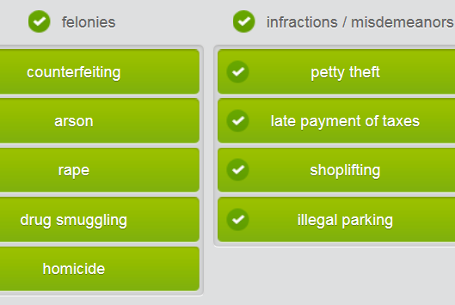

# Lexical_TypesOfIllegalDrugs (a link)

# Police and immigration I)

## Part 1)Types of crimes per severity

















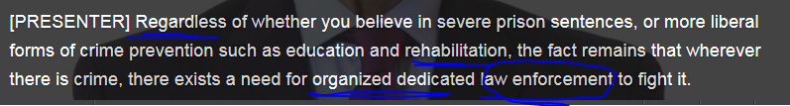

## STOP MP3

## Part 2) “crime prevention strategies犯罪预防”

## Types of crimes per severity

Would the following crimes be considered felonies, misdemeanors or infractions? Group the crimes accordingly.

|  |
| --- |
| **Categorizing Crime**  Criminal charges are typically classified as infractions, misdemeanors, or felonies, depending on the severity of the crime; the more serious the crime, the more serious the punishment.   Infractions  The least severe crimes are classified as infractions, which include most traffic and regulation violations. An infraction may not technically be considered a crime, depending on the circumstances. A person who commits an infraction will usually receive a ticket or a citation, and will not receive a jail sentence. An experienced lawyer may be able to negotiate a reduction of misdemeanor charges to the level of an infraction for first-time offenders, thus allowing them to avoid having criminal charges placed on their record.   Misdemeanors / petty crimes  A misdemeanor is a crime that is less serious than a felony but more serious than an infraction. The fines associated with a misdemeanor may be higher than for an infraction, and the offender may have to serve a jail sentence, though usually less than one year. Additionally, if a jail sentence is imposed, it is served at a local, city, or county jail, rather than at a state or federal prison. Theft of a value less than $500 is considered to be a misdemeanor. Also, some types of domestic violence may even be considered misdemeanor crimes.   Felonies   The most serious crimes of all are felonies, punishable by more than one year in prison. People who are convicted of a felony and are sentenced to prison will be held in a state or federal prison, rather than a local, city, or county jail. Crimes such as rape, homicide, counterfeiting, and drug smuggling are considered to be felonies, and can carry a sentence of up to life in prison or, in some countries, even death. |

## “Crime prevention” strategies犯罪预防的策略

The police officer is not convinced that prisoner **rehabilitation** programs work.

Very strict = draconian laws/rules/measures

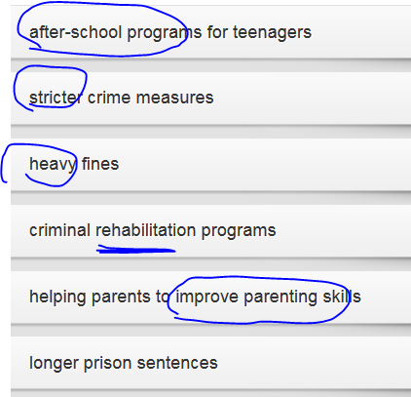

|  |
| --- |
| 1. I’d like to talk with you today about the effectiveness of our current **crime prevention** strategies .   2. Recently, initiatives such as **criminal rehabilitation programs** , which help recently-released criminals become **functioning** members of society, are a welcome step in the right direction.   3. Based on my experience, releasing criminals back into society after a long prison sentence can be a bit of a shock to them and many of them fail to fully integrate .   4. However, even though crime has dropped in some cities, it remains to be seen whether such **social programs** are the solution to the problem.   5. It’s not social programs that have helped to lower **the crime rate** but rather the enforcement of stricter crime measures . |

## Making ur points in a debate/argument

Listen to the radio debate between two police officers, one advocating tough measures on crime, one advocating education and **rehabilitation ['riːhə,bɪlɪ'teɪʃən]（罪犯的身心改造）**.

You have been asked to participate in a debate/argument on current crime prevention strategies. Before the debate/ argument, you and your colleagues are discussing your opinions. Decide if the phrases used in the debate are rude or not rude.

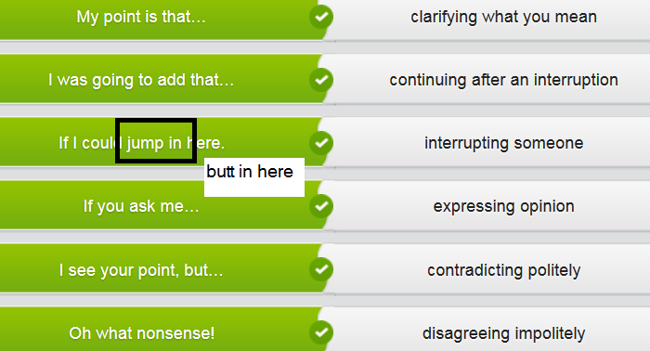

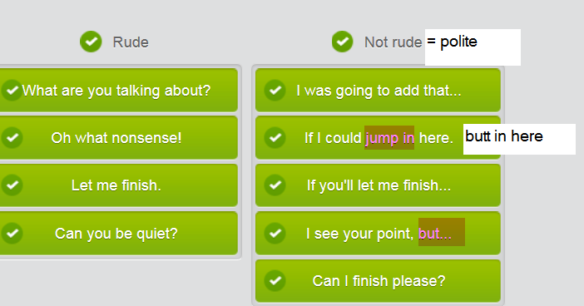

# STOP=================

## Part 3) VISA application

## VISA application terminology

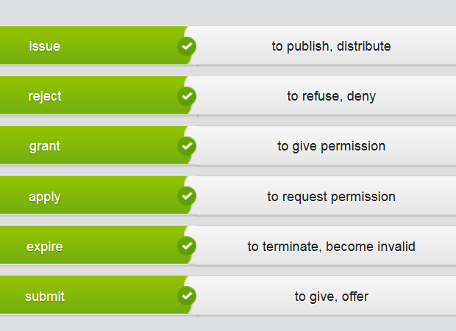

|  |
| --- |
| **REPUBLIC OF RIVENIA CUSTOMS AND IMMIGRATION**  **Guidelines for communicating with permanent resident visa applicants**   Agents should use this guide as a reference when talking with potential immigration applicants about visa eligibility and the visa application process.  Applicants can apply for Rivenian permanent resident status under the following categories: Family, Investment or Skilled Professional.   Under the Family category, citizens or permanent residents of Rivenia can sponsor their spouse, common-law partner or dependent child to become a permanent resident.   Applicants under the Investment category should have a minimum net worth of R$1,600,000 and make an R$800,000 investment in Rivenia.   Under the Skilled Professional category, workers with two years of experience in the professions listed below and a valid one-year work contract from a registered Rivenian employer are eligible to apply for permanent resident status.   1. Insurance Adjusters and Claims Examiners 2. Architects 3. Physicians 4. Dentists 5. Pharmacists 6. Physiotherapists 7. Psychologists 8. Social Workers 9. Electricians  10. Teachers   Each year Rivenia grants 80,000 permanent resident visas. There is a yearly quota for each category of immigrant. This year Rivenia will issue 30,000 Family category visas, 30,000 Skilled Professional category visas and 20,000 Investment category visas.  Applications for permanent resident visas will be rejected after the annual quota for each category has been met.      To apply to become a permanent resident of Rivenia, applicants are required to submit the application form along with a criminal record check, a medical certificate and the application fee of R$400. Applicants applying under the Skilled Professionals category must also submit both the originals and the official translations of educational degrees, diplomas and certificates, letters of reference, personal identification documents and/or sponsors’ letters.       A Rivenian permanent resident visa expires every five years and can be renewed at no cost. If an applicant’s visa expires before they are able to renew it, they must pay a fee of R$50 for renewal. |

## Describing visa application processes

Listen to the dialogue between a Rivenian immigration agent and a woman applying for permanent residency. Decide which application requirements were mentioned by the agent.

|  |
| --- |
| 1. That's fine, but you'll have to submit a few other documents before your application can be processed. First you need to submit **stamped official copies** of both your undergraduate degree and your medical degree.   2. No, in order to complete your application, I need three **sealed letters of reference** from your current and past employers.   3. Well, we will also accept letters of **reference** from your previous university professors. These should be **sealed** as well.  4. You should **submit a professional translation of any documents** that are not in Rivenian.   5. So let me just **go over** what I should submit for my final application. Along with my **application form** and the **application fee,** my health check and my criminal background check, I'll have to submit **stamped official copies** of my education certificates and three sealed letters of reference.   6. Once you've submitted your application, we'll send you a letter confirming that we have received it. The whole application process should take about one year. |

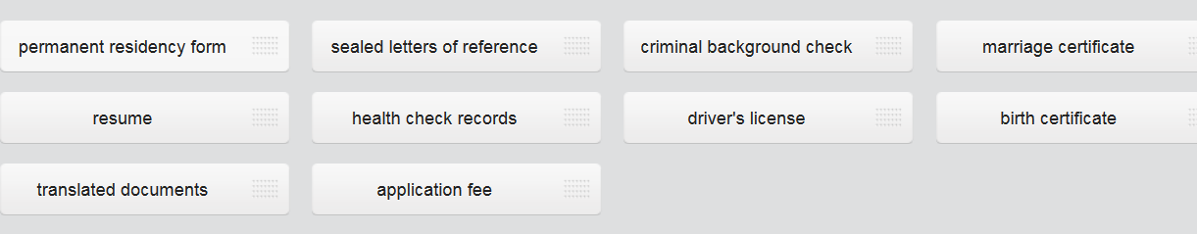

## Helping an applicant fill in a form

* You should print in capital letters only.
* Please use a black pen to fill in the form.
* Remember to sign your name in the correct place.
* Fill out the section for your passport number.

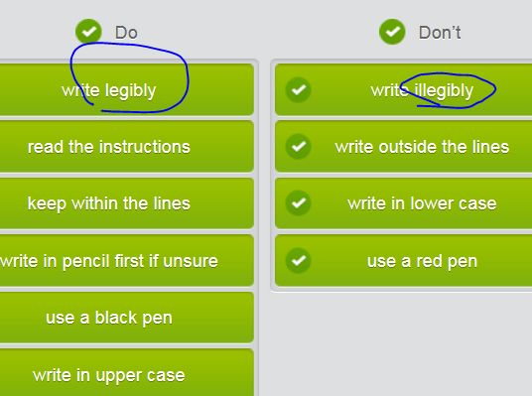

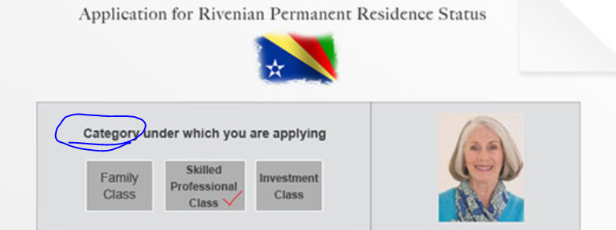

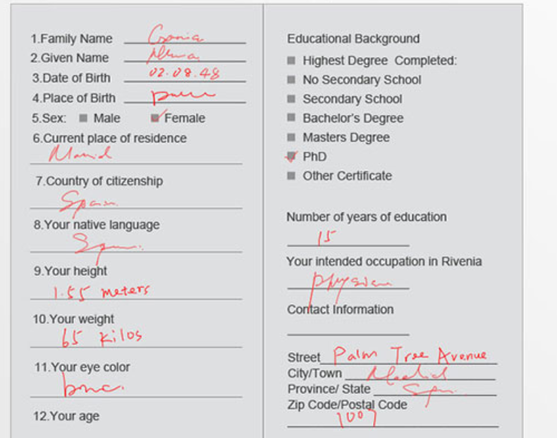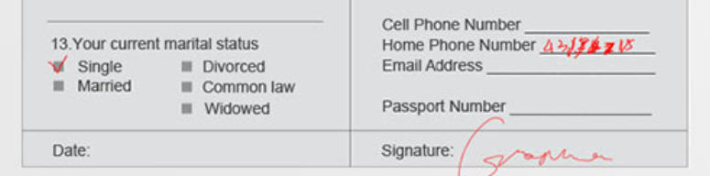

## Part4)

# Police and immigration II)

## Lexical_Types of crimes and corresponding punishment

## Part 1) Counterfeit赝品；冒牌货；伪造品

Border control agents see various types of **contraband/smuggling goods走私货** daily, from illegal drugs to **counterfeit ['kaʊntəfɪt] money/banknotes (假币)** to **knock-off (counterfeit) branded merchandise** and commodities.

The demand for these illegal goods requires agents to be constantly observant at entry points, including sea ports, airports, and land crossings. Among those **knock-off/counterfeit goods**, the illegal drugs are the most headache.

Drug smuggling/trafficking is a multibillion-dollar industry with an extensive network of **growers**, **smugglers**, and **human mules** all working together to distribute illegal drugs around the world.

//[**[ human mules ]**](javascript:;)**a person who is paid to transport illegal drugs for a dealer 受雇贩,走私运毒品者 e.g. Illegal goods are smuggled by human mules.**

## Negative social impact by illegal drugs

|  |
| --- |
| Illegal drugs affect all aspects of society, causing/wreaking a rise in violent crime, spreading detrimental diseases such as HIV virus, and even funding organized **crime syndicates(黑社会).** The drug trade is often connected to the distribution of **knock-off/counterfeit products假冒商品/赝品** and even **counterfeit money/banknotes(假币)**.  Although police officers and **law enforcement officials** are trained to recognize illegal goods and false documents, they also see the help of **sniffer dogs** as well as ordinary citizens to detect **contraband/smuggling goods**走私货.  Verifying **the authenticity of** banknotes and goods at the point of purchase is an important element in the fight against counterfeit/knock-off money.  Law enforcement officials and citizens alike are becoming more aware of these **counterfeit goods['kaʊntəfɪt]/knock-off goods假冒商品/赝品**, and are collaborating together to eliminate/get rid of/**eradicate** the demand for them.  Distributors of counterfeit/knock-off goods may think their dealings have just little effect on society. However, the lower-priced goods not only cause companies to lose revenues and cut jobs, but the poor quality of the fake products often makes them unsafe for consumers, esp. for children. |

# Ending

**In summary,** that’s why **law enforcement officials** are constantly on the look-out for illegal goods or **contraband (smuggling products走私货). Law enforcement officers** and ordinary citizens can work together to eliminate/get rid of the cycle, including demand, production, manufacturing, and distribution of counterfeit/knock-off goods, illegal commodities, and contraband (smuggling products).

## Part 2) Illegal drugs and prevent drug trafficking

## Lexical_TypesOfIllegalDrugs

|  |  |
| --- | --- |
| Name of the illegal drugs |  |
|  | ['ekstəsi] ecstasy, pl: ecstasies   1. [C,U] a feeling of extreme happiness 如痴如狂，欣喜若狂 **[ in (an) ecstasy ]** e.g. She was **in an ecstasy** of love. 她爱得如痴如狂。  **[ go into ecstasies (=become very happy and excited) 变得欣喜若狂 ]** 2. [U] ecstasy is an illegal drug that gives a feeling of happiness and energy. Ecstasy is especially used by people who go out to dance at clubs and parties. “狂喜”迷幻药 , 摇头丸 e.g. The teenager died after taking **ecstasy** 摇头丸 on her birthday.  e.g. An **ecstasy** overdose may cause heart damage.   V.S. 摇头丸; 非法的强致幻药物 LSD |
| 摇头丸; 非法的强致幻药物 | 摇头丸; 非法的强致幻药物 LSD: an illegal drug that makes you see things as more beautiful, strange, frightening etc than usual, or makes you see things that do not exist, or make you see something **illusive幻影的**; LSD is a very powerful illegal drug which makes the user see things that only exist in their mind. |
| 迷幻药 | PCP /ˌpiːsiːˈpiː/  [N-UNCOUNT](javascript:;)PCP is a drug that is used illegally for its hallucinogenic effects. PCP is an abbreviation for "phencyclidine." 迷幻药; phencyclidine的缩写 e.g.  Then she started doing PCP along with **pot大麻** and coke.  然后她开始用苯环己哌啶，还有大麻和可卡因。 |
| 兴奋剂[药]; | stimulant /ˈstɪmjʊlənt/   1. [N-COUNT](javascript:;)A stimulant is a drug that makes your body work faster, often increasing your heart rate and making you less likely to sleep; is a drug or substance that makes you feel more active and full of energy 兴奋剂[药] **[ artificial stimulants 人造兴奋剂 ]** e.g. It is not a good idea to fight fatigue by taking stimulants.  服兴奋剂来抗疲劳不是个好主意。 2. something that encourages more of a particular activity 刺激（物）[SYN](javascript:;) STIMULUS  **[ economic stimulants 经济刺激因素; a stimulant to sth = a stimulus to sth对<xxx> 是一种刺激]**   e.g. Increases in new construction would be **a stimulant to the economy**. 新建设项目的增加 对<经济可能> 是一种刺激。  V.S. **sports doping [ 体育比赛说的] 兴奋剂** |
| **[ 体育比赛说的] 兴奋剂** | ['dəʊpɪŋ] doping or **sports doping**  n. [体育]使用(或服用)兴奋剂  v. （dope的ing形式）给…服用毒品; 强迫…吸毒  the practice of using drugs to improve performance in a sport  使用违禁药物〔以提高体育比赛的成绩〕  doping scandal/ban/test etc  doping offences 服用药物的违规行为 |
| n. 鸦片；麻醉剂 adj. 鸦片的 | ['əʊpɪəm] opium n. 鸦片；麻醉剂 adj. 鸦片的  [词条图片](javascript:;)   Opium is a powerful drug made from the seeds of a type of poppy. Opium is used in medicines that relieve pain or help someone sleep. 鸦片  Opiates are narcotics derived from the poppy plant.  =>['pɒpɪ] poppy or poppy plant; 复数 poppies V.S. puppy = tiny small dog  n. 罂粟花; 深红色 adj. 罂粟科的  [词条图片](javascript:;)   1. [N-COUNT](javascript:;)A poppy is a plant with a large, delicate flower, usually red in colour. The drug opium is obtained from one type of poppy. 罂粟 e.g....a field of poppies …一块罂粟地。 2. [ADJ](javascript:;)of or relating to pop music 流行音乐的 |
| 鸦片制剂; 用于镇痛或催眠;  **〔让人忘却生活中烦恼的〕精神慰藉物，(精神)麻醉剂/精神鸦片〔含贬义** | opiate /ˈəʊpiːɪt/ An opiate is a drug that contains opium, which is used as a **narcotic**麻醉剂. Opiates are used to reduce pain or to help people to sleep. 鸦片制剂; 用于镇痛或催眠。   1. Literal meaning: opiate is a drug that contains opium. Opiates can be used to reduce severe pain and help people to sleep. 鸦片制剂，麻醉剂〔用于止痛和安眠〕 2. Figurative meaning: opiate is something that makes people stop thinking about the problems, the daily grinds[graɪnd]日常琐事,and headaches in their lives so that they can try to make their lives better – used to show disapproval**。〔让人忘却生活中烦恼的〕精神慰藉物，(精神)麻醉剂/精神鸦片〔含贬义〕** e.g. Hollywood movies were seen as an **opiate** for the people. 好莱坞影片曾被视为人们的 **精神鸦片**。 |
| 麻醉剂; 毒品 | narcotic /nɑːˈkɒtɪk/  1.  [N-COUNT](javascript:;)Narcotics are drugs such as opium or heroin which make you sleepy and stop you from feeling pain. You can also use narcotics to mean any kind of illegal drugs. 麻醉剂; 毒品  e.g.  He was indicted for dealing in **narcotics**.  他因贩卖毒品而受到起诉。  e.g. They use opium as narcotics.  2. [ADJ](javascript:;)If something, especially a drug, has a narcotic effect, it makes the person who uses it feel sleepy. 麻醉的  e.g.  ...hormones that have **a narcotic effect** on the immune system.…对免疫系统 有麻醉作用 的激素。  V.S.  **镇静剂tranquilizer/ˈtræŋkwəlaɪzə/ = sedative /ˈsɛdətɪv/**   * A **tranquilizer** is a drug or medicine that makes people **feel calmer or less anxious.** Tranquilizers are sometimes used to make people or animals become **sleepy** or unconscious. * A **sedative** /ˈsɛdətɪv/ is a medicine or drug that calms you or makes you **sleep**. 镇静剂 |
| (手术中用的) 麻醉剂；麻药 | [,ænɪs'θetɪk] anaesthetic  adj. 麻醉的  n. (手术中用的) 麻醉剂；麻药  [N-MASS](javascript:;)Anaesthetic is a substance that doctors use to stop you feeling pain during an operation, either in the whole of your body when you are unconscious, or in a part of your body when you are awake. 麻醉药  •  The operation is carried out under a general anaesthetic.   这个手术是在全身麻醉下进行的。  麻醉剂  under anaesthetic  •The operation will have to be done under anaesthetic (= using anaesthetic ) . 手术得在麻醉状态下进行。  •Eye surgery is often performed using a local anaesthetic (= one that only affects a particular area of your body ) . 眼科手术常在局部麻醉下进行。  •You will need to have a general anaesthetic (= one that makes you completely unconscious ) . 你得接受全身麻醉。  DERIVATIVE 派生词  anaesthetic adj [only before noun]  •anaesthetic drugs 麻醉药 |
| (巴比妥类)催眠药 | (巴比妥类)催眠药barbiturate /bɑː**ˈbɪtjʊrɪt**/  [N-COUNT](javascript:;)A barbiturate is a drug which people take to **make them calm or to help them to sleep.** (巴比妥类)催眠药  e.g.  She has serious insomnia and she was so addicted to barbiturates.  她对(巴比妥类)催眠药 有了依赖性。  e.g. Barbiturates depress the central nervous system. |
| 精神药物 | [‚saɪkəʊ'æktɪv]  **[ psychoactive drugs ]**  have an effect on your mind; significantly affects mental ability 〔药物〕作用于精神的，影响心理状态的 |
| 大麻 | **marijuana /ˌmærɪˈhwɑːnə/  = pot大麻**  Marijuana or pot is a drug which is made from the dried leaves and flowers of the hemp plant, and which can be smoked. 大麻  e.g.  Then she started doing PCP along with **marijuana  /pot大麻** and coke.  然后她开始用苯环己哌啶，还有大麻和可卡因。 |
|  | heroin /ˈhɛrəʊɪn/: Heroin is a powerful drug which some people take for pleasure, but which they can become addicted to. 海洛因  e.g. Heroin is one of the most addictive drugs in the world. |
|  |  |
| 冰毒〔一种毒品〕 | 冰毒〔一种毒品〕 methamphetamine  [,meθæm'fetəmiːn; -ɪn] an illegal drug that gives a feeling of energy |

## STOP=================

## **Illegal Drugs and deadly effects on the User**

|  |
| --- |
| **Illegal Drugs and Their Effects on the User**  Illegal drugs are typically classified as depressants, stimulants, opiates, hallucinogens and psychoactive drugs. Their effects on the human body and mind are numerous and range in severity from slight to life-threatening.   Depressants are drugs that temporarily reduce the function of a part of the body or impair mental processes. As the name would suggest, these types of drugs make the user feel depressed, and are often called “downers.” Examples of depressants include barbiturates, which are drugs that impair the central nervous system, and produce effects such as sedation and anesthesia.   Stimulants, on the other hand, are drugs that temporarily enhance mental or physical function. Users may feel more alert and awake, and as a result, stimulants are often referred to as “uppers.” However, this temporary improvement often comes at the cost of the user’s health. For example, cocaine, a highly addictive drug that comes from the leaves of the coca plant, can cause an increased heart rate, delusions, and may even induce heart attacks. Similarly, methamphetamines increase alertness, and produce euphoria, but may cause delusions and damage the circulatory system.  Opiates are narcotics that are derived from the opium poppy plant. Opiates are often used to reduce pain, but can also be highly addictive. Examples of opiates include opium, which is then converted into heroin, one of the most addictive drugs known to mankind. Heroin almost always causes dependence, decreased liver function and slower respiratory function.  Hallucinogens cause changes in perception, thought, emotion and consciousness, with no basis in reality. Examples of hallucinogens include PCP, which is typically smoked, and causes aggressive behavior, convulsions, and paranoia; and LSD, which is either taken orally or injected, and which causes altered senses and emotions, increased heart rate and tremors.  Finally, psychoactive drugs act primarily upon the central nervous system and affect brain and physical function. Although marijuana has some medicinal uses, it normally causes increased heart rate, impairment of memory, and loss of motor coordination and concentration. Ecstasy is an example of a psychoactive drug, and generally causes euphoria and arousal. However, overdoses may cause anxiety, hallucinations, and even damage to the heart. |

## Making recommendations-eliminate drug trafficking.

Listen to the following conversation between a radio talk show host and a member of the Drug Enforcement Administration (DEA) about eliminating drug trafficking.

|  |
| --- |
| 1. Most importantly, I think we should impose stricter legal penalties on drug traffickers and pushers, including longer prison sentences.  2. To help with this, parents ought to start talking to their children about the dangers of illegal drugs from a younger age.  3. Also, it might be a good idea to form community watch groups in the neighborhood to help alert police of drug trafficking activity in the area.  4. And how about redesigning our public spaces with more lighting and strategic fencing to help protect our neighborhoods?  5. If we really want to eliminate the illegal drug trade, we'd better create drug rehabilitation programs that not only help users to get over their addictions, but also help eliminate the desire for illegal drugs from the beginning.  6. Yes! If I were them , I’d start looking for a different job! |

## Describe the impact of drugs on society

While doing research for your presentation on preventing and combating illegal drug trafficking, you found an informative web page describing the impact of illegal drugs on society.

|  |
| --- |
| **The Impact of Drugs on Society**  We are often told to just say “no” to drugs, and that's excellent advice. Drugs have various adverse effects on individuals and society. Besides the obvious health dangers of taking drugs, there are many other ways in which drugs negatively impact our communities.   Many people think that their own health is their own business, but perhaps you didn’t know that drug use also contributes to the spread of HIV. This can be caused by the sharing of drug needles, but HIV is also spread as a result of the impaired abilities of users to make good judgments. Drug users often engage in unprotected sex, which then transmits HIV to several people in a short period of time.   Closely related to this is the burden that drugs have on the health care system, since so much money and resources are spent treating drug addicts, victims of drug-related violence, and others whose health is affected by the illegal drug trade.   Drug use also brings about great economic losses in the community. Drug users tend to have lower productivity at work, or they miss work altogether, costing companies millions of dollars per year. Additionally, millions of dollars are spent every year fighting drug cartels and drug smugglers.   All of the fighting between drug cartels, drug smugglers, and the authorities not only results in millions of dollars in property and infrastructure damage, but also increased violent crime in our neighborhoods. Drug users are often violent as a result of the influence of drugs or the influence of their desire for them.   Related to this is the funding of militant groups that comes as a result of drug trafficking. These groups sometimes commit acts of violence and terrorism in order to establish their dominance and take control of the drug trafficking industry.   Finally, even when we do capture those responsible for selling or importing drugs, the justice system becomes burdened as a result of having to deal with the perpetrators of drug-related crimes. |

To help you organize your thoughts in preparation for your presentation on preventing and combating illegal drug trafficking, rank the consequences of illegal drug trafficking from most damaging to least damaging to society.

* The drug trade causes an increase in violent crime.
* Drug trafficking helps fund militant groups.
* Economic losses occur as a result of drug use.
* Drug-related crimes burden the justice system.
* Drug use negatively affects the health care system.

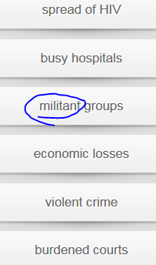

## Prevent drug trafficking

It's time for your presentation on preventing and combating illegal drug trafficking. Talk about the current trends in drug trafficking prevention. Use the model audio and the bullet points to help you.

Current trends in **drug trafficking prevention**  
  
•    Most common types of illegal drugs  
•    Going after the drug cartels  
•    Community watch groups  
•    Better drug education and better drug **rehabilitation/rehab** programs  
•    Redesigning public spaces   
•    Stricter / more **draconian** legal penalties   
•    Talking to children about drug use at a younger age

## Part 3)Domestic abuse(DA)/violence家庭暴力

How much do you already know about domestic abuse? The following statements refer to statistics gathered in the UK.

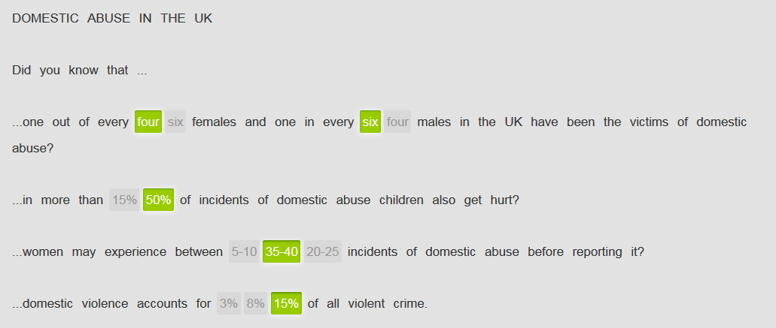

## Types of domestic abuse (DA) /violence家庭暴力

|  |  |
| --- | --- |
| Physical domestic abuse/violence | Emotional domestic abuse/violence |
|  |  |
| People associate this crime with hitting, kicking or punching between family members in the ‘comfort’ of their own homes, causing **black-and-blue**  **['blækən'blu:] 被打得青紫的** marks on their body. | Well, emotional abuse can be harder to pin down sometimes, but abusers can say or do things that threaten the victim, or that undermine their confidence and self-esteem. |
| Along with physical violence, there is often also sexual assault , where one family member forces another into some kind of unwilling **intimate** contact. | Invariably, verbal abuse is mixed in with all of that. It starts with name calling, but then escalates to **belittling[bi'litliŋ]** and constantly criticizing the family member, in order to humiliate them.  //If you **belittle** someone or something, you say or imply that they are unimportant or not very good; formally to make someone or something seem small or unimportant; 轻视；贬低 e.g.He tends to **belittle her efforts**. 他往往 **轻视她的努力** |
|  | In extreme cases, abusers attempt to **manipulate操纵控制** and isolate their victims by limiting their contact with others outside of the home. They are even able to convince their victims that they are to blame for the abuse.  //**控制和操纵（某人；某人的思想); 控制/操纵sb做xxx** If you say that someone **[ manipulates people to do sth]** , you disapprove of them because they skilfully force or persuade people to do what they want.  e.g. She's always **manipulating me to** give her vast sums of money. 控制我让我给她大笔的钱。 |

## SOADA['səʊda]-Methods of dealing with domestic abuse (DA)

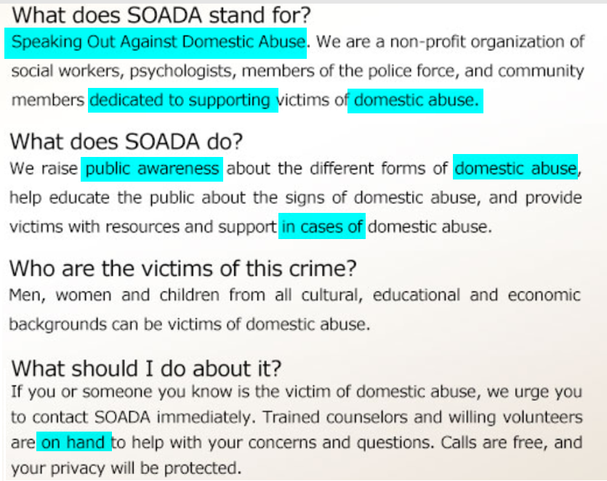

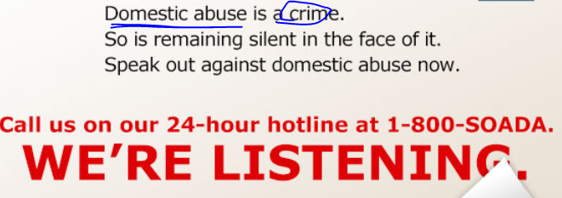

Ms. Smith, a member of the **neighborhood watch group居委会**, has contacted your department asking for information on how to deal with domestic abuse. Write her an email summarizing the information from the **SOADA flyer**, and encourage her to contact the organization.

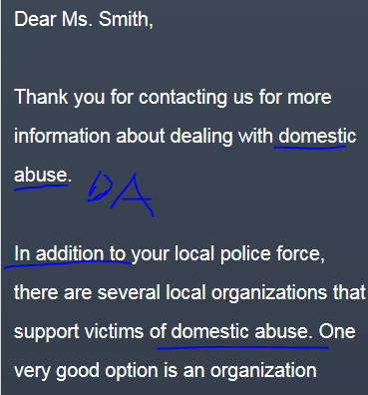 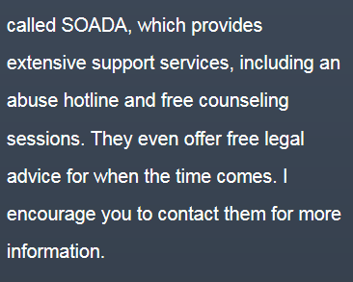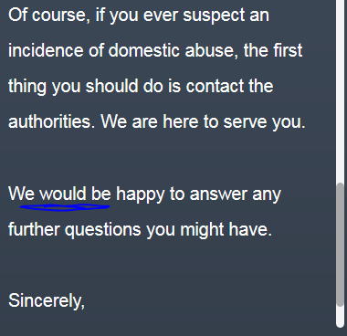

## Asking questions to gather information

You are helping to train new volunteers at the **SOADA  ['səʊda]** center. Listen as one of the trainees takes a call on the **domestic abuse(DA)** hotline.

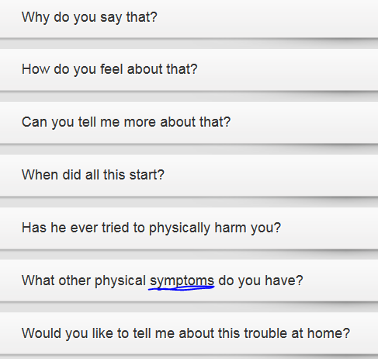

## Part4) Counterfeiting and counterfeit goods假货/赝品

Read the posts from the online forum. Decide how many of the people who posted bought something illegal.

Reviews for Quay West Market

Terry0101          Tuesday 08:31

My friend went to Quay West Market last week. He was looking for a nice present for his wife’s birthday – a designer bag and some expensive perfume. But he later found out that they were counterfeit. Just wanted to warn everyone that Quay West is selling fakes!  
____________________________________________________

Jane1357           Tuesday 09:12

That’s horrible. I had no idea that Quay West sold counterfeit goods. I just bought a movie from the DVD store there. I’d better check it to be sure it’s genuine. I’d hate to think I have a pirated copy on my hands. Thanks for the heads up.  
____________________________________________________

Bill9876              Tuesday 10:26

I had a similar experience. Some guys tried to sell me a really expensive brand of watch there last night. I noticed right away that it was made of inferior materials - the strap was really cheap-looking. I agree with Terry0101. Buyer beware at Quay West.  
____________________________________________________  
  
Milly3535            Tuesday 15:48  
  
I just heard on the news that the police just raided Quay West Market! It turns out there was an international counterfeiting cartel that was flooding the market with everything from computer software to alcohol and cigarettes. The managers at Quay West have been detained for questioning. Looks like they’re shutting the market down.

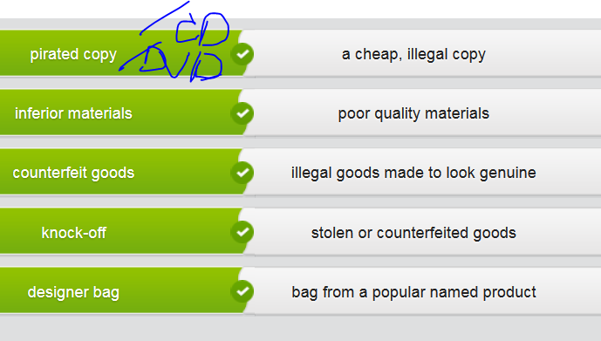

Read the next entry in the online consumer forum and fill in the gaps.

currency  -  knock-off  -  pirated copies  -  logos  -  desirable brands

I’ve always shopped at Quay West and love it. Why should we have to pay high prices for fancy images and logos ? The big corporations are the real fakes. They contract out work to underdeveloped countries, pay the workers next to nothing but charge the customers inflated prices. That’s not right, no matter what currency you pay in. I mean, what exactly is it about these desirable brands that makes them so desirable? Everybody ends up wearing the same things – do people really think they’ll be more like a pop star or sports star if they do? And as for pirated copies of DVDs, well, more power to them. Everything is way too expensive anyway! No wonder there were so many knock-off goods at that market.

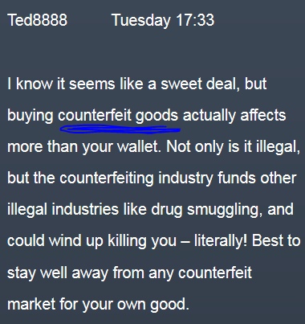

## Types of counterfeit goods假货/赝品

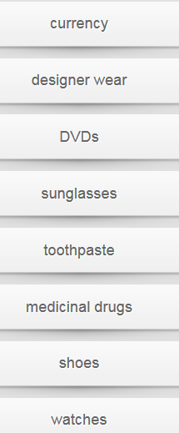

## Counterfeit consumer goods

How much do you know about counterfeiting? Read the statements about common counterfeit consumer goods

|  |  |  |  |
| --- | --- | --- | --- |
| A Word To The (Street) Wise  https://cns2.ef-cdn.com/Juno/10/86/56/v/108656/Pol2.4.2.2_magazine-400.jpg   |  |  |  | | --- | --- | --- | | It’s Saturday afternoon and the market’s crowded with the usual shoppers, all looking for a bargain. Instead of spending your day at the glitzy designer stores at the Urban Village Shopping Mall, you join the crowd of people gathered at the knock-off market. You notice one vendor selling cheap designer handbags and accessories, and you think about how trendy you would look wearing that watch or those fashionable shoes. Who could blame you for wanting a bargain? But after you understand the real cost this multi-million dollar counterfeiting industry has on the global economy, you may change your mind.     It’s estimated by the International Chamber of Commerce that counterfeit goods comprise 5 to 7% of global trade. The majority of these products are common, household goods we use every day - cigarettes, alcohol, perfume, DVDs, clothing, shoes and accessories, computer supplies and software, and electronic goods like batteries. Even toothpaste makes the list in |  | a few countries. However, even though a product is fake, it will probably cost the same as the real thing. Not only are you getting an inferior quality product, but you’re also not saving any money!  On the one hand, some people argue that major corporations are making millions of dollars in profit and need to be challenged. Perhaps counterfeiters are doing a community service? On the other hand, the more we as consumers buy these knock-off goods, the more we contribute towards job losses when the brand-name company’s profits go down. What’s more, when drugs, foods and electronic products are fake, they can be seriously dangerous because of the poor quality of the product; they can even be fatal in some cases, so it’s best to avoid counterfeit goods altogether.   Don’t miss the second article in this series highlighting the dangers of counterfeit pharmaceutical products in next month’s edition. It could save your life! | |

## Grammar

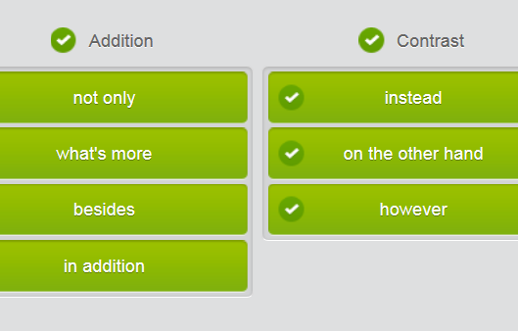

## Modern trends in counterfeiting

Which of these counterfeit goods do you think are most harmful to society?

Oh, these days they’ve left behind the **pirated videos盗版** and **the pirated DVDs盗版** and are now into **counterfeiting drugs.** You may remember the case of the senior citizen who died having bought cheap prescription drugs over the Internet thinking she was saving some money. Instead, the poor dear lost her life. What’s more, the money from **counterfeited pharmaceutical products** often goes towards funding **the street drugs街头毒品** that have become such a terrible problem in some of our modern cities. **Not only** *does* the drug problem increase, but it also leads to more violence on the streets and gang warfare as different groups try to control the illegal drug trade. Shocking really, and very dangerous. Instead of saving someone’s life, counterfeit drugs could even be fatal/deadly , as we see all too often now.

## Creating a counterfeiting web page

You and your colleagues are brainstorming information to include on the counterfeiting web page. Now prepare the content for an informative web page about counterfeit goods. Be sure to keep the following points in mind: **types of counterfeit goods**  -  **the effect of counterfeiting on society** -  the signs of a fake - what to do if you discover a knock-off

Counterfeiting 101



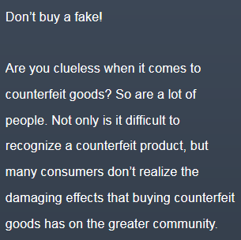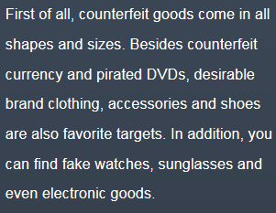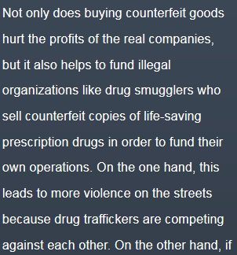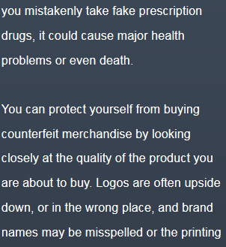

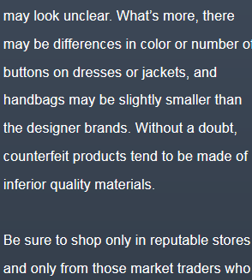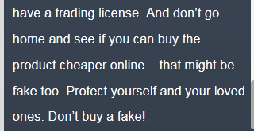

# Police and immigration III)

## Part 1) Illegal immigration ways





















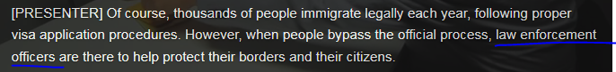

## Part 2)Summarize the details of a case

## Methods of illegal immigration

Read the information on the training web page about the most common methods of illegal immigration. Answer the questions.

|  |  |  |
| --- | --- | --- |
| Illegal Immigration   |  | | --- | | https://cns2.ef-cdn.com/Juno/11/90/24/v/119024/Pol3.2.1.1_header.jpg | | **The most common methods**  Illegal immigration is a crime that affects all aspects of our society. As a border control agent, it is important for you to understand the most common methods of illegal immigration so that you can better serve our fellow citizens.  First, it is important to know what is meant by the term “illegal immigration”. Simply put, it describes people who enter or remain in a country without formal permission, so they are there illegally rather than lawfully.   The most subtle and least serious form of illegal immigration is overstaying one's visa, which is considered a civil offence. An immigrant might enter the country legally, but when they stay longer than permitted or violate the provisions of their visa, they have committed an infraction and may have to pay a fine or they may be deported, or both.   On the other hand, crossing the border of a country illegally is considered a federal crime. Immigrants from other countries who do not qualify for an entry visa may try to sneak across the border to gain entry. Although this tends to happen quite often because of economic reasons, with people migrating from poorer countries to richer countries, it can happen in almost any country for any reason.   Two even more serious methods of illegal immigration are people smuggling and people trafficking. Many people think these two phrases refer to the same offence; however they are two very different crimes.  People smuggling takes place with the consent of the person being smuggled illegally into a country, whereas people trafficking is the illegal trade in human beings, usually for the purpose of forced labor or sexual exploitation. Either way, a person can be hidden from the authorities in the cargo of a boat or truck, for example, or they can pass through checkpoints using fraudulent passports or other counterfeit documents. | |

## Grammar - compare

How does the training web page **compare** the different types of illegal immigration? Fill in the sentences using the words and phrases below. Use the web page to help you.

although  -  either way  -  however  -  least  -  most  -  on the other hand  -  rather than  -  whereas

1. Simply put, it describes people who enter or remain in a country without formal permission, so they are there illegally lawfully.  
  
2. The subtle and serious form of illegal immigration is overstaying one's visa, which is considered a civil offence.  
  
3. , crossing the border of a country illegally is considered a federal crime.  
  
4. this tends to happen quite often because of economic reasons, with people migrating from poorer countries to richer countries, it can happen in almost any country for any reason.  
  
5. Many people think these two phrases refer to the same offence; they are two very different crimes.  
  
6. People smuggling takes place with the consent of the person being smuggled illegally into a country, people trafficking is the illegal trade in human beings, usually for the purpose of forced labor or sexual exploitation.  
  
7. , a person can be hidden from the authorities in the cargo of a boat or truck, or they can pass through checkpoints using fraudulent passports or other counterfeit documents.

## Answer

1. Simply put, it describes people who enter or remain in a country without formal permission, so they are there illegally rather than lawfully.  
  
2. The most subtle and least serious form of illegal immigration is overstaying one's visa, which is considered a civil offence.  
  
3. On the other hand , crossing the border of a country illegally is considered a federal crime.  
  
4. Although this tends to happen quite often because of economic reasons, with people migrating from poorer countries to richer countries, it can happen in almost any country for any reason.  
  
5. Many people think these two phrases refer to the same offence; however they are two very different crimes.  
  
6. People smuggling takes place with the consent of the person being smuggled illegally into a country, whereas people trafficking is the illegal trade in human beings, usually for the purpose of forced labor or sexual exploitation.  
  
7. Either way , a person can be hidden from the authorities in the cargo of a boat or truck, or they can pass through checkpoints using fraudulent passports or other counterfeit documents.

## People smuggling V.S. people trafficking

Immigrants who are **smuggled** across the border illegally and immigrants who are **trafficked** across the border unwillingly are dealt with differently by the authorities.

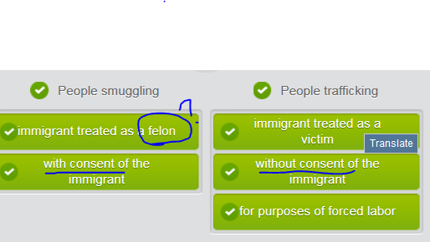

Either way, **overstaying** a visa is an **infraction (violation or breach of a rule/laws)**.

Similarly, people smuggling is also a federal crime.

On the other hand, crossing the border is illegal.

Rather, trafficked immigrants are treated as victims.

## Arrest and detention terminology

Match the arrest and detention vocabulary words with the phrases with similar meanings.

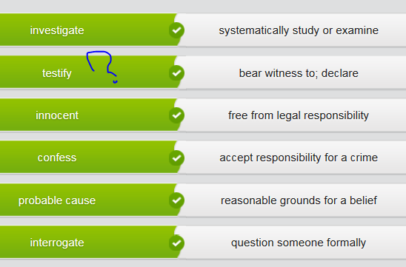

## Procedure of arresting sb.

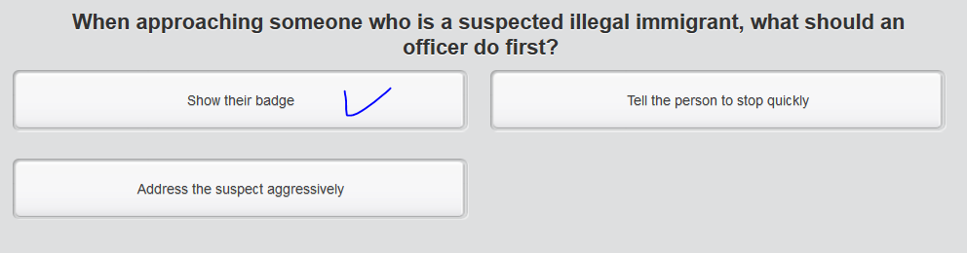

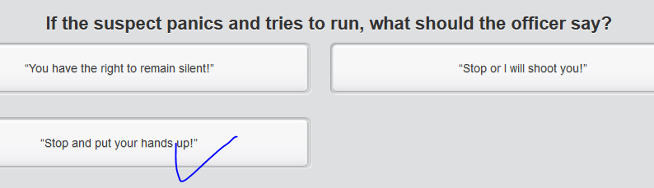

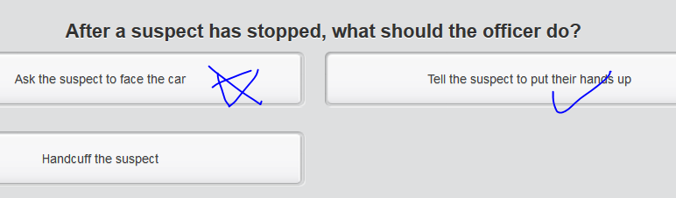 to make sure they’re “unarmed”

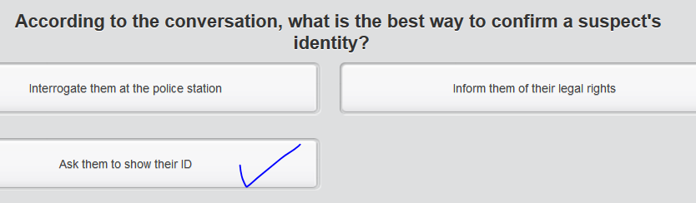

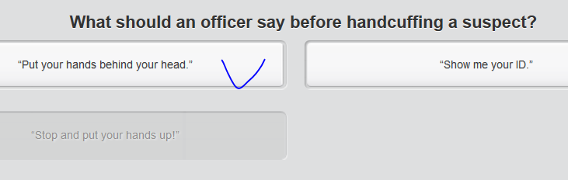

//V) handcuff sb.

## Procedure of detaining a suspect:

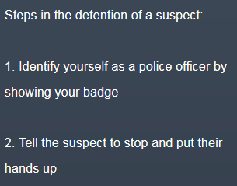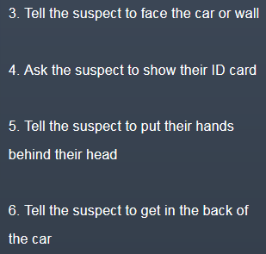

## Part 3)Report the seizure of illegal goods〔警方或政府官员对毒品、枪支等的〕查获，没收

// when the police or government officers take away illegal goods such as drugs or guns 〔警方或政府官员对毒品、枪支等的〕查获，没收; When an organization such as the police or customs makes a seizure of illegal goods, they find them and take them away. 缴获; 没收  
e.g. Police have made one of the biggest seizures of heroin 缴获的海洛 there's ever been.

## Common illegally shipped goods

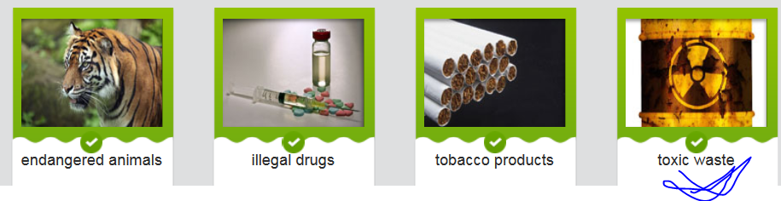

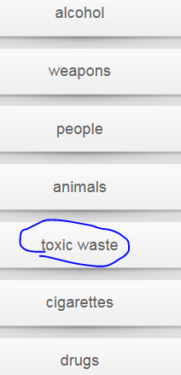 endangered animals

|  |  |  |
| --- | --- | --- |
| THE ROAD TO TRANSPORTING ILLEGAL GOODS   |  |  | | --- | --- | | The high seas have long been associated with acts of piracy, and modern day illegal trade continues to plague international waters. These days, the high seas and its container and passenger ships remain prime suspects when it comes to the transportation of illicit goods, especially when there is a high volume of goods in question. | https://cns2.ef-cdn.com/Juno/10/87/30/v/108730/Pol3.3.1.1_illegal-goods-resized.jpg |   Of course, the shipment of goods between countries is governed by many laws as part of import and export policies, and trade agreements. Every country has a list of goods which are prohibited from being shipped into the country. These can include hazardous materials like toxic waste, weapons such as guns and tanks, and endangered animals or diseased plants.   These policies are enacted to protect the physical, financial and national security of a country, but sometimes politics play a part too. For example, the importation of Cuban cigars is banned in the US because of its political relationship with that country, which has unwittingly created a demand for illegally shipped tobacco.  //[**[ human mules ]**](javascript:;)**a person who is paid to transport illegal drugs for a dealer 受雇贩,走私运毒品者 e.g. Illegal goods are smuggled by human mules.** **Human mules** are contracted by drug smugglers to carry illegal drugs across international borders, either by swallowing the drugs or by otherwise hiding them on their person. Not long ago, black market goods were discovered on board a ship, hidden in insulation rolls. And in recent years, we’ve seen a rise in illegal human cargo, people who are squeezed together like sardines in a tin with no light and little air circulation, just to cross a border.   It seems smugglers will try every trick in the book to make sure their cargo is transported successfully to its destination, but border control is ever vigilant, helping to reduce the amount of illegally shipped goods that cross the border into the country. |

Illegal goods are smuggled by **human mules. （1.** 骡 2. a person who is paid to transport illegal drugs for a dealer 受雇贩,走私运毒品者 e.g. Illegal goods are smuggled by **human mules.）**

**Black market** goods are hidden from authorities.

Hazardous materials like **toxic waste** are prohibited.

**Endangered animals** were found in the cargo.

Illegal weapons and ammunition were discovered and seized.

## Grammar:using the passive voice

Read the sentences and fill in the correct form of the verb. Use the newspaper article on illegally shipped goods to help you.

For example: Of course, the shipment of goods between countries is governed by many laws.

|  |
| --- |
| Of course, the shipment of goods between countries is governed (govern) by many laws.  Every country has a list of goods which are prohibited (prohibit) from being shipped into the country.  These policies are enacted (enact) to protect the physical, financial and national security of a country.  For example, the importation of Cuban cigars is banned (ban) in the US because of its political relationship with that country.  Human mules are contracted (contract) by drug smugglers to carry illegal drugs across international borders.  Not long ago, black market goods were discovered (discover) on board a ship.  And in recent years, we’ve seen a rise in illegal human cargo, people who are squeezed (squeeze) together like sardines in a tin.  It seems smugglers will try every trick in the book to make sure their cargo is transported (transport) successfully to its destination.  e.g. |

## Reporting the details of a crime

Your colleague has written a report about **the interception of a shipment of illegal tobacco products** at the port.

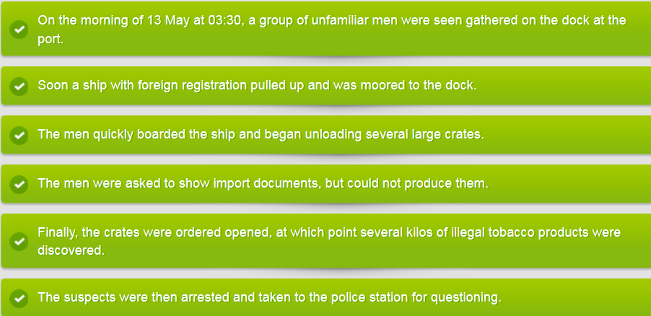

## Reporting **the seizure of illegal goods**〔警方或政府官员对毒品、枪支等的〕查获，没收

You followed up on your **informant’s tip-off线人的线报**, and seized a shipment of illegal tobacco products brought in by ship. Which points will you include in your report? Which will you **leave out**?

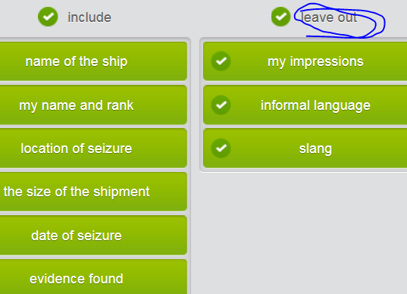

Report **the seizure of illegal goods**

Read the rough notes you took during the phone call and immediately after the **raid**. Use them to write your official report on the incident. Remember to use clear and formal language to describe the incident.

Notes:

|  |
| --- |
| •    Who: Barry Black and Wayne White •    What: a large shipment of cigarettes •    When: Friday morning at 2:30 •    Where: at the dock  •    How: by yacht (Empress of the Seas)  Phone call @ midnight “Shirley” Shipment coming in to port. Friday 13th. Reliable??  Several suspects tried to flee the scene, most captured and detained. Included 3 human mules. Barry Black. Year-long investigation. Possible connection to drug smuggling?  $5 million in black market cigarettes, cigars. Largest shipment to date! (No drugs found)  Shipment logged on return to station, 4:54 am, Friday the 13th May. Unlucky day for Black. |

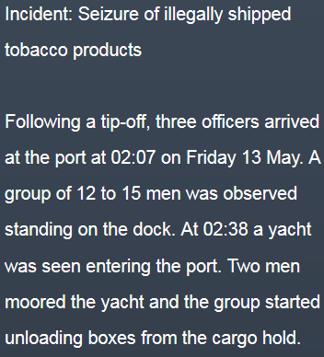 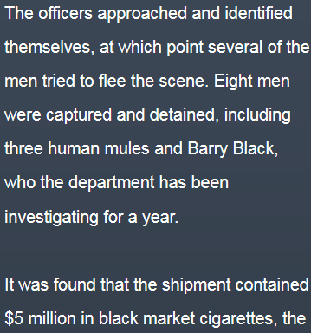 

## Part4) Interrogate a suspect

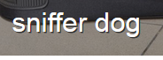 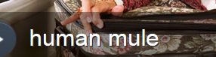

 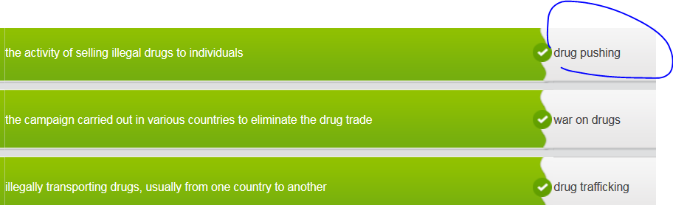

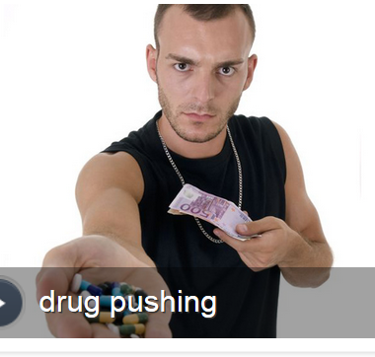 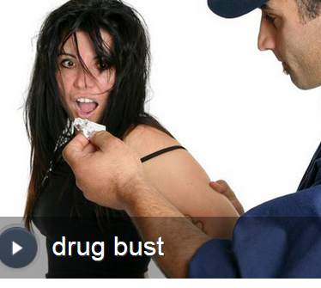

## International drug smuggling

Read the newspaper article about the arrest and detention of a reputed **drug lord**

**//druglord**/ˈdrʌɡˌlɔːd/[**N**](javascript:;)**a criminal who controls the distribution and sale of large quantities of illegal drugs 大毒枭**

|  |
| --- |
| REPUTED DRUG LORD ORDERED DETAINED  Antonio Banditeros, reputed to be the biggest drug trafficker on the East Coast, was ordered held without bail Tuesday on federal drug and gun charges.  https://cns2.ef-cdn.com/Juno/10/87/64/v/108764/Pol3.4.1.2_drugs-resized.jpgJudge Barry McDrew’s decision to detain Banditeros until his trial marks the culmination of the highly publicized war on drugs. Drug enforcement agents last week carried out what has been called the biggest drug bust in more than a decade. Banditeros was taken in a sting operation in an otherwise quiet penthouse suite overlooking Central Park.  Banditeros faces various drug smuggling charges, including conspiring to distribute cocaine and heroin. If convicted, he could receive a life sentence, prosecutors said. He has pleaded not guilty.  DEA officials say Banditeros’ far-reaching recruitment allowed officials to plant undercover agents in his organization and, after a year-long investigation, gather enough evidence to bring down the core of his operation.   According to court records, Banditeros started drug pushing on New York City streets as a teenager. “He wasn’t interested in just selling marijuana to college kids with substance abuse problems,” said the DEA official who masterminded the sting operation. “From the moment he set foot in the Empire State, this guy had his eye on building his own drug-smuggling empire.”   Banditeros aspired to become the baron of a multimillion-dollar drug cartel, and he scouted for partners within the justice system as well as in low-income neighborhoods, according to documents filed in the case. With the help of these accomplices, he was able to create a global organization whose sole purpose was to control the price and flow of illegal drugs in New York and elsewhere.   In addition, several secondary leaders also were detained, including Jerry Green, reputed right-hand man of Banditeros. He is also being held without bail pending trial. |

## fill in the words

Read the sentences and fill in the words from the list below. Use the newspaper article to help you.

**drug bust  -  drug cartel  -  drug trafficker -  drug pushing  -  drug smuggling  -  substance abuse  -  war on drugs**

1. Antonio Banditeros, reputed to be the biggest drug trafficker on the East Coast, was ordered held without bail Tuesday on federal drug and gun charges.  
  
2. Judge Barry McDrew’s decision to detain Baditeros until his trial marks the culmination of the highly publicized war on drugs .  
  
3. Drug enforcement agents last week carried out what has been called the biggest drug bust in more than a decade.  
  
4. Banditeros faces various drug smuggling charges, including conspiring to distribute cocaine and heroin.  
  
5. According to court records, Banditeros started drug pushing on New York City streets as a teenager.  
  
6. “He wasn’t interested in just selling marijuana to college kids with substance abuse problems.”  
  
7. Banditeros aspired to become the baron of a multimillion-dollar drug cartel . //**大毒枭drug lord /ˈdrʌɡˌlɔːd/**[**N**](javascript:;)**a criminal who controls the distribution and sale of large quantities of illegal drugs**

## Talking about **degree of certainty**

We'll have to talk to his accomplices.

We could start by asking him some leading questions.

Well first off, we need to **establish rapport with** him.

We'll start interrogating him next week.

## **Eliciting information from** a detained suspect 从sb.那里**引出/套出话**

Use the following “strategy” to **elicit information from a person**:

|  |
| --- |
| 1. You packed the suitcase yourself, **didn't you ?** => rhetoric question  2. You are quite forgetful, **aren't you** , Mr. Green?  3. **Isn't it** true that you have been working for Banditeros for the last ten years?  4. **Wouldn't you** say that you two are close friends?  5. So you know him pretty well, then, **don't you** ?  6. And you could also say that he trusts you**, isn't that right** ?  7. **So y**ou admit that you conduct business for Banditeros?  8. **Do you remember** being at the Lion Hotel last month? |

# STOP MP3======

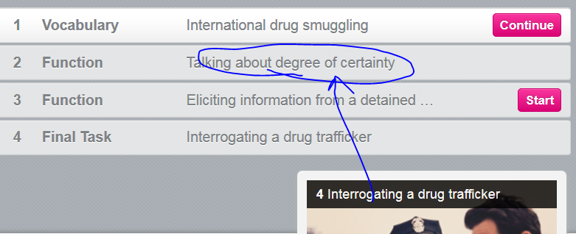

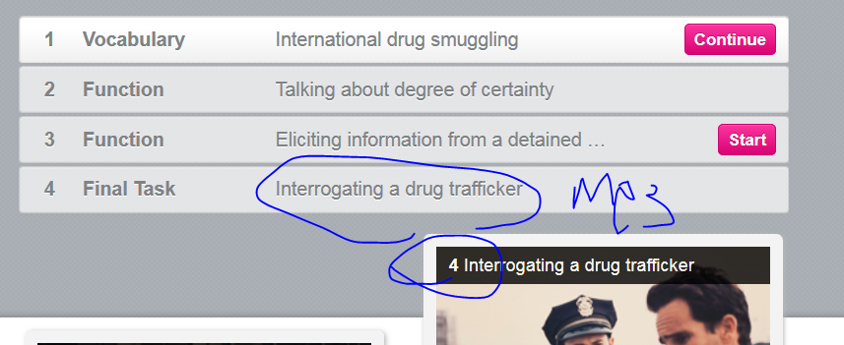

# CNN

## Illegal migration (copy to EF migration unit)

<https://edition.cnn.com/2018/06/07/africa/un-sanctions-migrant-traffickers-intl/index.html>

## Illegal migration (copy to EF migration unit)

<https://edition.cnn.com/2018/06/07/africa/un-sanctions-migrant-traffickers-intl/index.html>

*(CNN)*Six men who allegedly **made fortunes** from buying and selling vulnerable migrants have been hit by United Nations sanctions in an **unprecedented/all-time** response to the international slave trade/**human trafficking** [exposed by CNN](https://cnn.com/2017/11/14/africa/libya-migrant-auctions/index.html), the Dutch foreign ministry said Thursday.

Four Libyans and two Eritreans are **accused of** leading criminal networks that traffic vast numbers of **vulnerable migrant**s through Libya to Europe. **Strikingly**, one of them is a commander with the Libyan Coast Guard, whose efforts to stem the flow of migrants are supported in part by funding from the European Union. He is **accused of/indicted for** using firearms to deliberately sink boats carrying migrants. Another is accused of having **longstanding** links with ISIS and is known for "cultivat[ing] relationships with terror groups," according to UN documents obtained by CNN.

Others in the group are accused of selling migrants as "sex slaves" and being responsible for some of the worst migrant boat disasters in the **Mediterranean**. The motion for **sanctions** was **filed to** the UN Security Council's Libya sanctions committee by The Netherlands. Russia put a "technical hold" on the motion in May and requested more evidence, but dropped its objection on Thursday.

It's the first time the committee has **slapped international sanctions** on individuals for **human trafficking**.

Dutch prosecutors describe the men as **ostentatious** with their wealth and acting with **impunity**. "The sanctioned individuals are young, mostly 30-something, and people who really want to spend their money; on their militia, their business, but also on properties and goods all over the world. They feel **untouchable**. Dutch Foreign Minister told CNN the sanctioning of the Coast Guard commander "shows that we will go to whatever place concerned in finding and punishing the people responsible, even if it is an organization that we are working together with in other fields."

Documents obtained by CNN show how the men profited from the **smuggling** and exploitation of migrants and **refugees** in a network that spanned Africa. "This **abuse** has reached an **unprecedented**/all-time scale and level of severity, and these illicit activities have resulted in thousands of fatalities on land and sea. This **cynical** business model has enabled armed groups to **accumulate** vast wealth," it adds. The **sanctions imposed** will freeze the six men's financial assets including personal bank accounts and the revenue from their global business activities. The six men will also **be subject to** strict travel **blanket bans**.

"These sanctions will help stop the flow of **blood money** ... It will prevent them from buying protection in Libya which in turn can destabilize the region," the Dutch National Prosecutors' Office said.

|  |
| --- |
| [ɪn'fest] infest; infestation V.S. [ inflict/cause some damage  ]    |TEM8 (infestinginfestedinfests)  1.  [V-T](javascript:;)When creatures such as insects or rats infest plants or a place, they are present in large numbers and cause damage. (昆虫或老鼠等) 大批出没于  •  ...pests like aphids which infest cereal crops.   …像蚜虫那样大肆侵害谷类作物的害虫。  2.  [ADJ](javascript:;)大批出没的  •  The prison is infested with rats.   那座监狱里鼠满为患。  3.  [V-T](javascript:;)If you say that people or things you disapprove of or regard as dangerous are infesting a place, you mean that there are large numbers of them in that place. 充斥着  •  Crime and drugs are infesting the inner cities.   犯罪和毒品充斥着市中心区。  4.  [ADJ](javascript:;)成群危害的  •  The road further south was infested with bandits.   更南边的公路盗匪猖獗。  MEANINGS 义项  1.  if insects, rats etc infest a place, there are a lot of them and they usually cause damage  〔昆虫、老鼠等〕成群侵扰，大批出没于  be infested with sth  •The kitchen was infested with cockroaches. 厨房里到处是蟑螂。  shark-infested/rat-infested etc  •shark-infested waters 鲨鱼成群出没的水域  2.  if things or people you do not want infest a place, there are too many of them  〔不想要的人或物〕遍布于  •an area infested with holiday homes 到处都是度假屋的地区  DERIVATIVE 派生词  infestation n /͵ɪnfɛsˋteʃən ; ‚ɪnfe'steɪʃən / [C,U]  V.S.   [ɪn'flɪkt]  MEANINGS 义项  1.  [T] to make someone suffer something unpleasant  使〔某人〕遭受〔不愉快的事〕，使承受  •Detectives warned that the men could inflict serious injury. 警探提醒说这些人可能会造成严重伤害。  inflict sth on/upon sb  •The strikes inflicted serious damage on the economy. 罢工给经济造成了巨大损失。  2.  inflict yourself/sb on sb  to visit or be with someone when they do not want you – used humorously  不请自来/把某人硬塞给某人〔幽默用法〕  •Was it really fair to her friends to inflict her nephew on them? 把她外甥硬塞给她的朋友，这对她们真的公平吗？ |
| [blood money ]  1. money paid to the family of someone who has been murdered 〔偿付给被害人亲属的〕抚恤金[N-UNCOUNT 不可数名词](javascript:;)If someone makes a payment of blood money to the family of someone who has been killed, they pay that person's family a sum of money as compensation. 付给被杀者亲属的抚恤金  •  Defence lawyers have still not agreed to terms for payment of blood money to the victims' families.   辩方律师尚未同意向被害人亲属支付抚恤金的条款。  2. money paid for the killer or hitman to murdere someone 血腥钱〔指付给杀手或打手的酬金〕  Blood money is money that is paid to someone for murdering someone. 付给杀手的酬金 |
|  |